

Capstone Project Report
Report 6 – Software User Guides

- Ho Chi Minh, 04/2025 -
Table of Contents
I. Record of Changes 3
II. Release Package & User Guides 4
1. Deliverable Package 4
2. Installation Guides 4
2.1 System Requirements 4
2.2 Setup Files 5
2.3 Installation Instruction 5
3. User Manual 9
3.1 Overview 9
3.2 Web application 9
3.3 Mobile application 31

I. Record of Changes
Date | A*  M, D | In charge | Change Description
30/04/2025 | A | Luân | Add document from final report
*A - Added M - Modified D - Deleted

II. Release Package & User Guides

1. Deliverable Package
No. | Items | Sub-items | Type | Version
Code package
1 | Web application module | SP25SE026_GSP48_WDCRBP_WebApp.zip | New | 1.0.0
2 | Mobile application module | SP25SE026_GSP48_WDCRBP_Mobile.zip | New | 1.0.0
3 | Web API module | SP25SE026_GSP48_WDCRBP_API.zip | New | 1.0.0
Database
1 | Initialise Database | db-create-script.sql; db-insert-script.sql | New
Document
1 | Final project report | WDCRBP_Final_Report.docx

2. Installation Guides

2.1 System Requirements

2.1.1 Web application
Spec | Minimum | Recommend
Internet connection | LAN, internet access capability | LAN, Wi-fi (16 Mbps)
Processor | Intel Core i5 1.5GHz | Intel Core i7 2.6GHz
Memory | 4GB RAM | 8GB RAM up
Storage | 4GB | 6GB up

2.2.2 Mobile application
Spec | Minimum | Recommend
Internet connection | 3G connection, internet access capability | 4G/5G Wi-Fi stable connection
Processor | Quad-core 1.5GHz | Octa-core 2.0GHz or higher
Memory (RAM) | 2GB RAM | 4GB RAM or more
Storage | 2GB free space | 4GB free space or more

2.2.3 Web API
Component Name | Version | Description
Operating System | Windows 10/11, Linux, Ubuntu | Run the server application
Database | MySQL 8 | Data storage for application
Runtime Framework | Java 23, Spring Boot | Run backend APIs

2.2 Setup Files
- db-create-script.sql; db-insert-script.sql: Database script for system
- SP25SE026_GSP48_WDCRBP_API.zip: API for services
- SP25SE026_GSP48_WDCRBP_WebApp.zip: Web application for browser use
- SP25SE026_GSP48_WDCRBP_Mobile.zip: Mobile application for mobile use

2.3 Installation Instruction

2.3.1 Setup Database
- Install MySQL 8 by following guidelines link: MySQL download: Cài đặt MySQL trên Windows, MacOS, Linux - ITviec Blog

2.3.2 Setup Back-end API
- Install Intellij Ultimate by following guidelines link: Hướng dẫn cài đặt intellij
- Extracting: SP25SE026_GSP48_WDCRBP_API.zip
- Open folder as IntelliJ IDEA Project
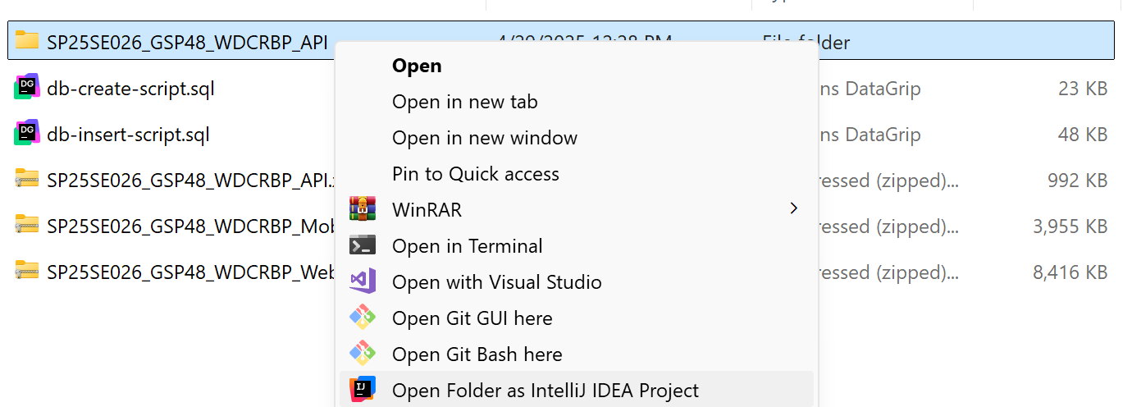
- Config your database connection
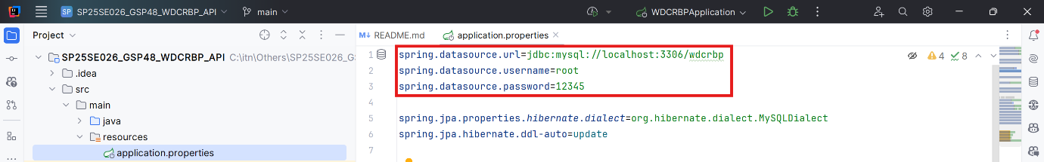
- Run project
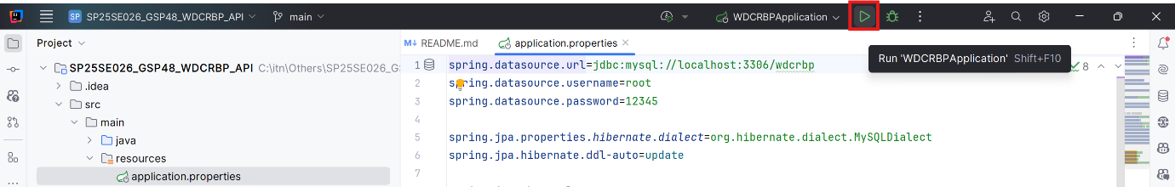
- Test project in browser by go to url: http://localhost:8080/swagger-ui/index.html#/

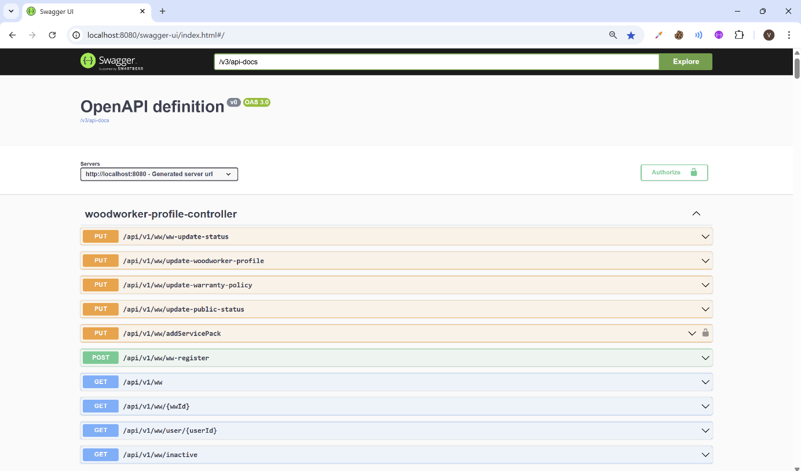

2.3.3 Setup Web Application
- Install Visual Studio Code by following guidelines link: Cài Visual Studio Code lập trình C/C++ - IT DESIGN
- Install npm through Visual Studio Code or you can install npm via NodeJS Node.js — Run JavaScript Everywhere
- Extract SP25SE026_GSP48_WDCRBP_WebApp.zip and open folder with Visual Studio Code
- Open terminal and enter npm i:
- Change API_URL based on your backend configuration
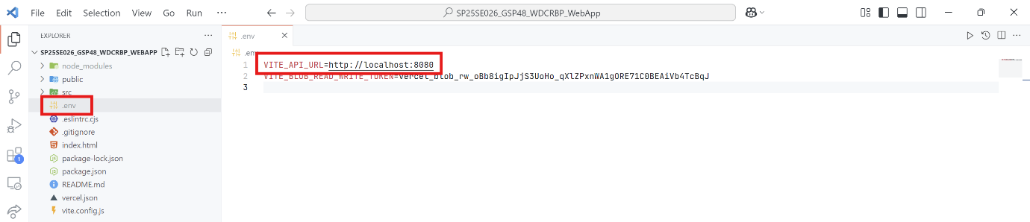
- In terminal, enter npm run dev
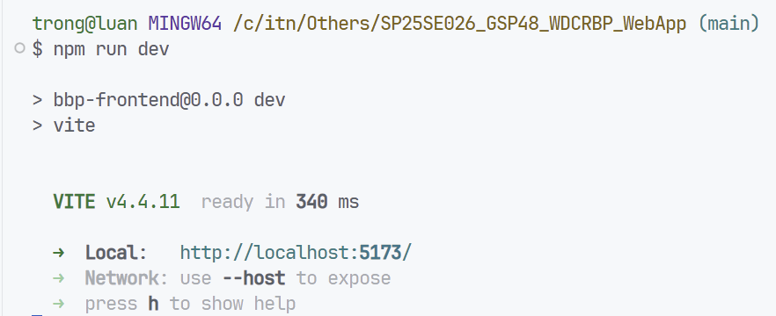
- Project start with http://localhost:5173/
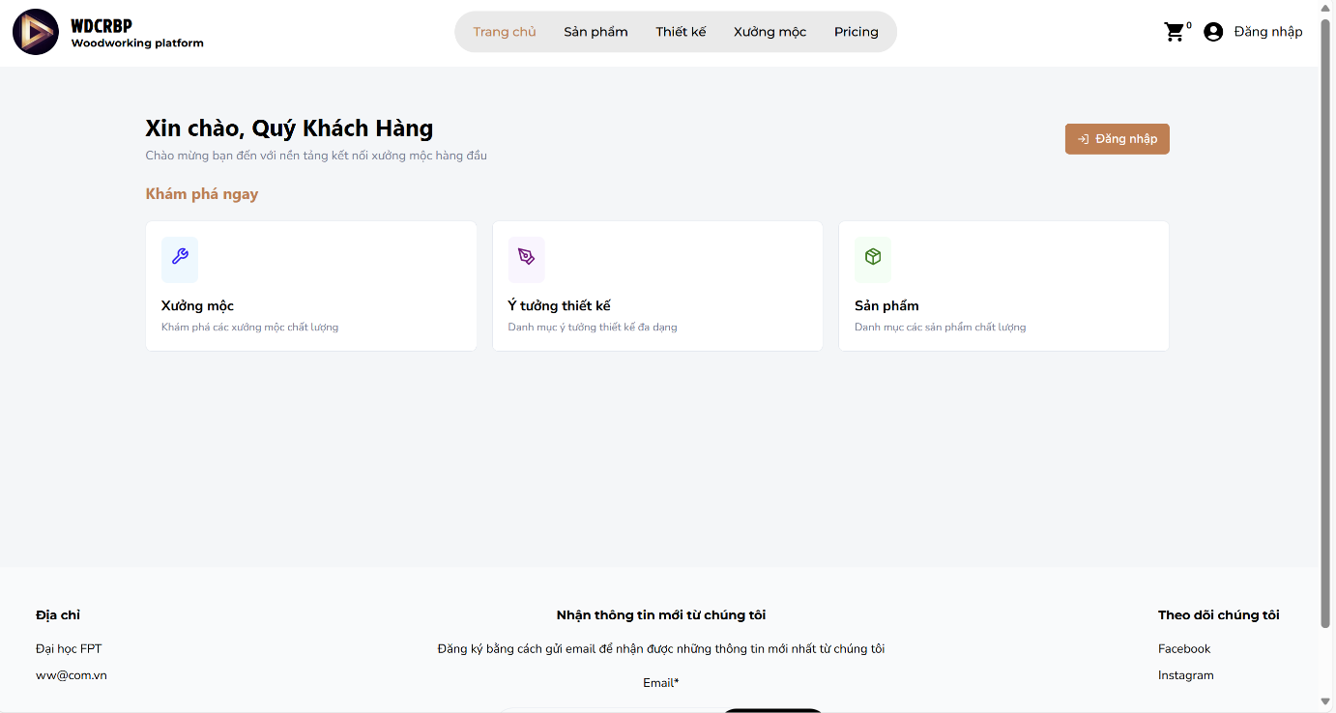

2.3.4 Setup Mobile Application
- Open terminal in visual studio code and enter: npm install --global yarn
- Install Bluestack by following guidelines link: Cách cài đặt giả lập BlueStacks để chơi game Android trên máy tính, PC
- Run Bluestack and install Expo Go: Expo Go - Ứng dụng trên Google Play
- Extract SP25SE026_GSP48_WDCRBP_Mobile.zip and open folder with Visual Studio Code
- Open terminal and enter yarn install:
- Change API_URL based on your backend configuration
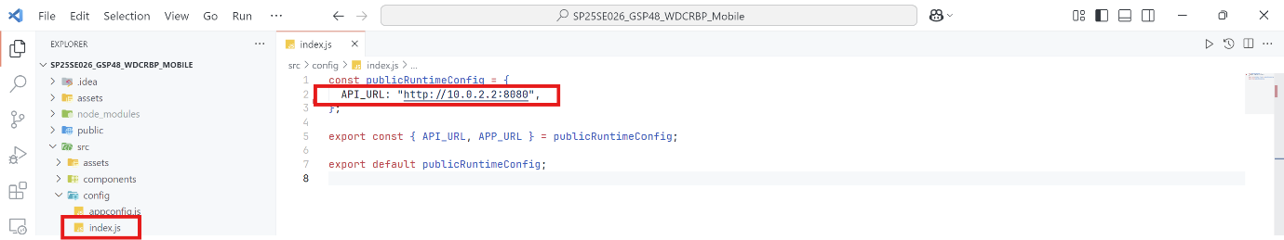
- In terminal enter yarn start
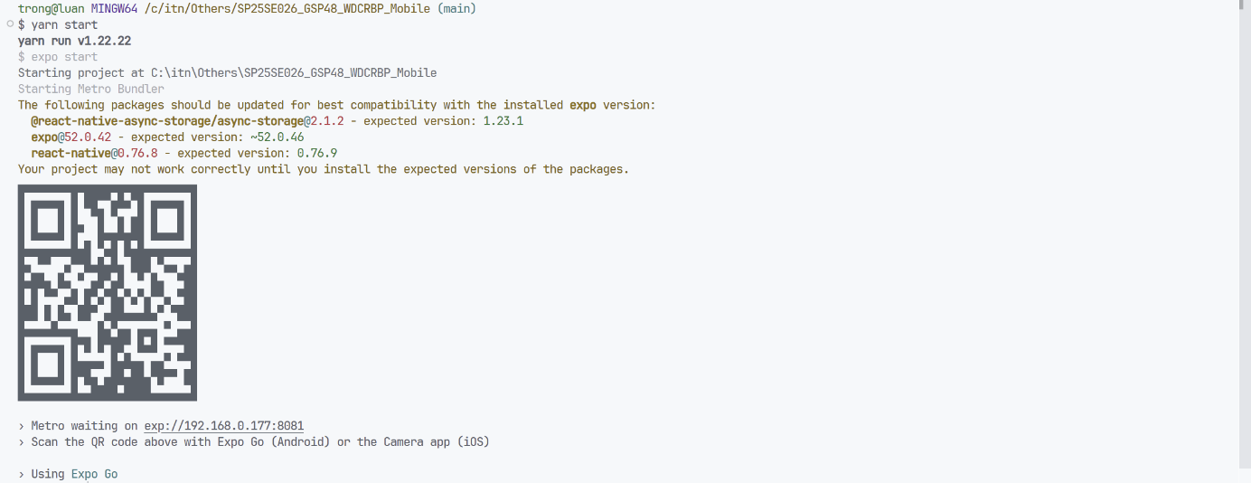
- Open Expo Go in BlueStack and enter URL: exp://192.168.0.177:8081 then click Connect
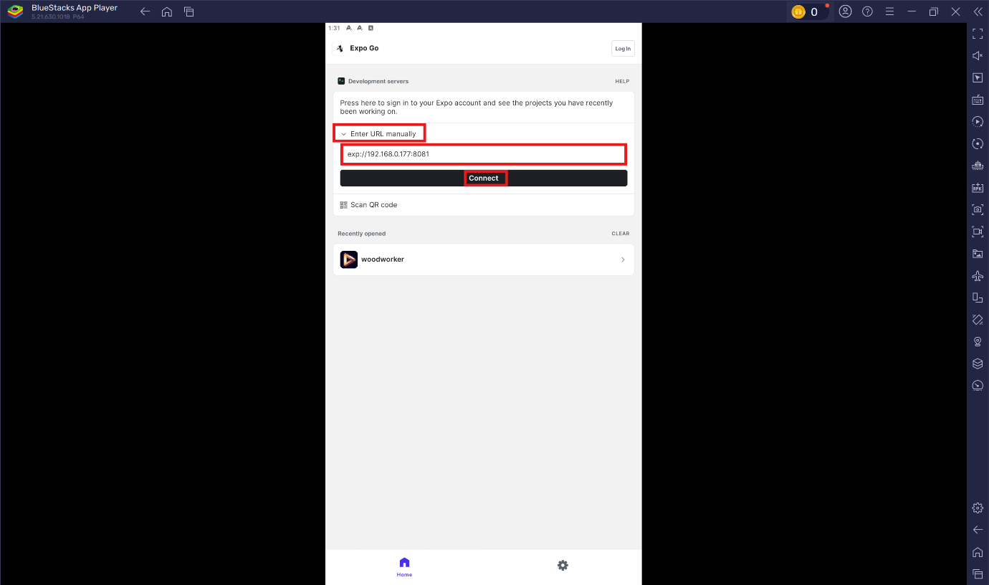
The application will start after connecting
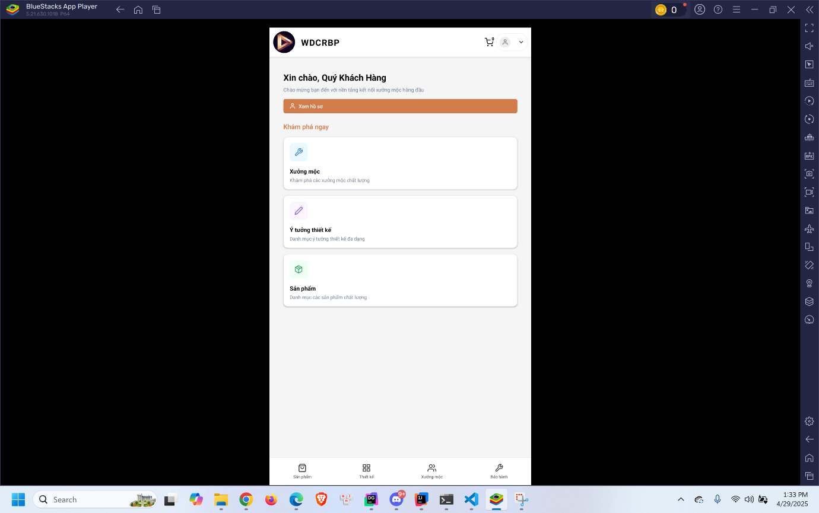

3. User Manual

3.1 Overview
Our platform is a dynamic marketplace connecting woodworkers and customers for personalized furniture solutions. Users can register, offer, or book services seamlessly, focusing on customization, personalization, and guarantee services to ensure high-quality, made-to-order products. The system is designed to empower woodworkers to showcase their craftsmanship and enable customers to easily configure and request.

3.2 Web application

3.2.1 Woodworker Registration Feature

3.2.1.1 Guest register as a woodworker
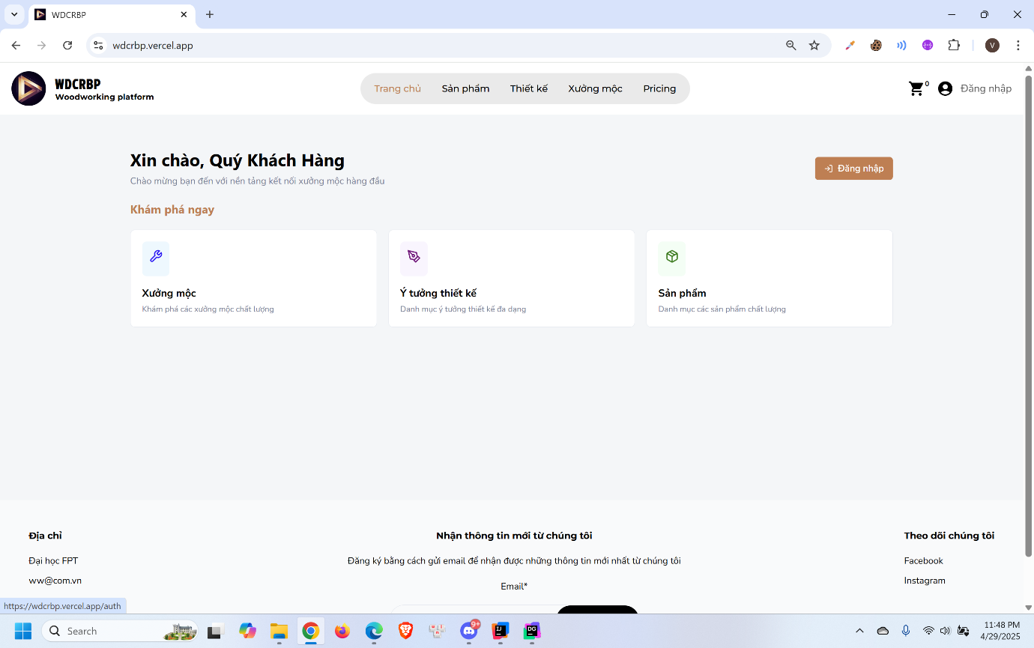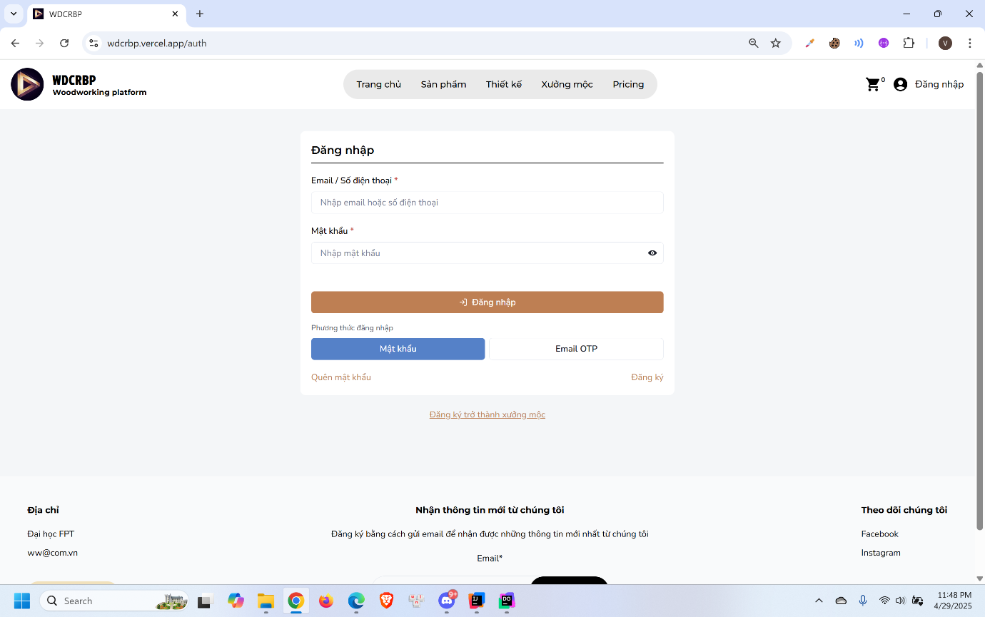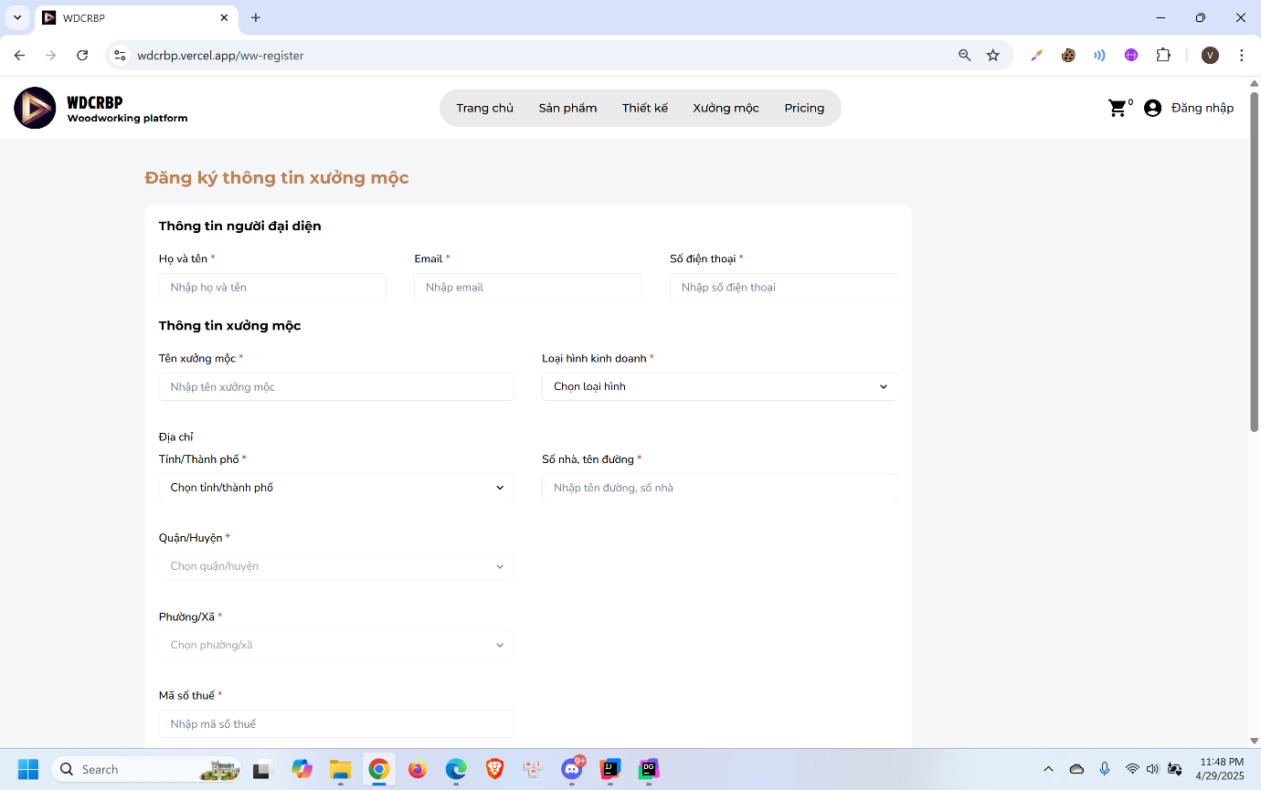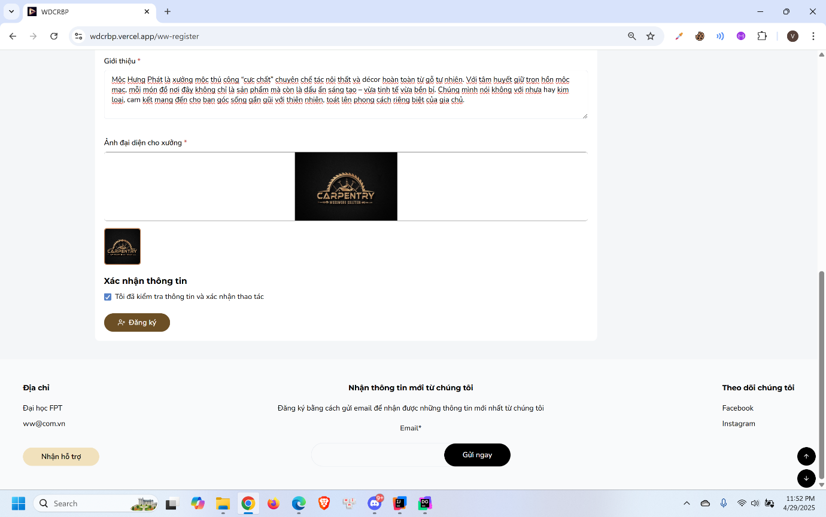
- Click ”Đăng nhập”
- Click “Đăng ký trở thành xưởng mộc”
- Fill in the registration form
- Click “Đăng ký”

3.2.1.2 Admin approve woodworker registration
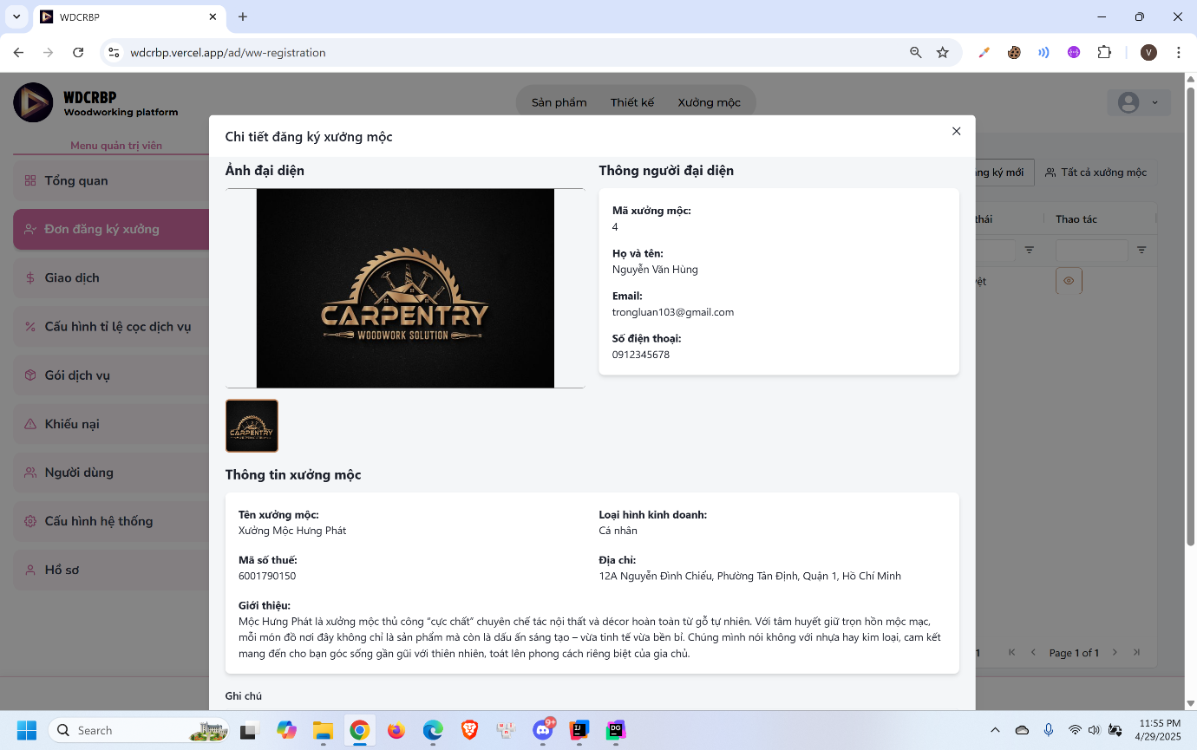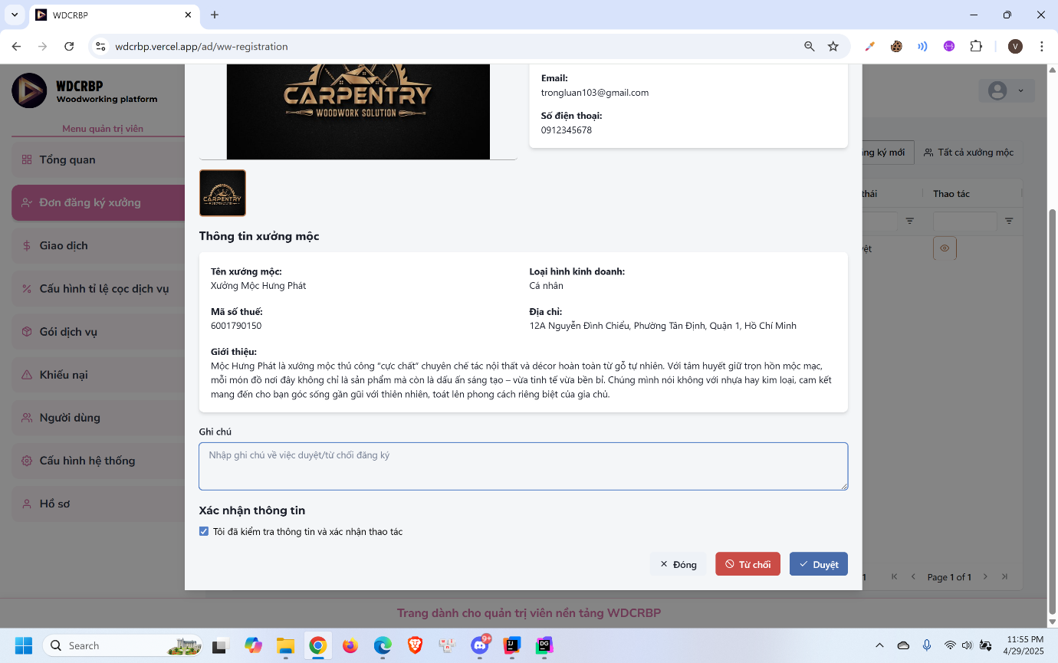
- Click “Đơn đăng ký xưởng”
- Click “Chi tiết”
- Click “Duyệt

3.2.1.3 Woodworker deposit money to wallet
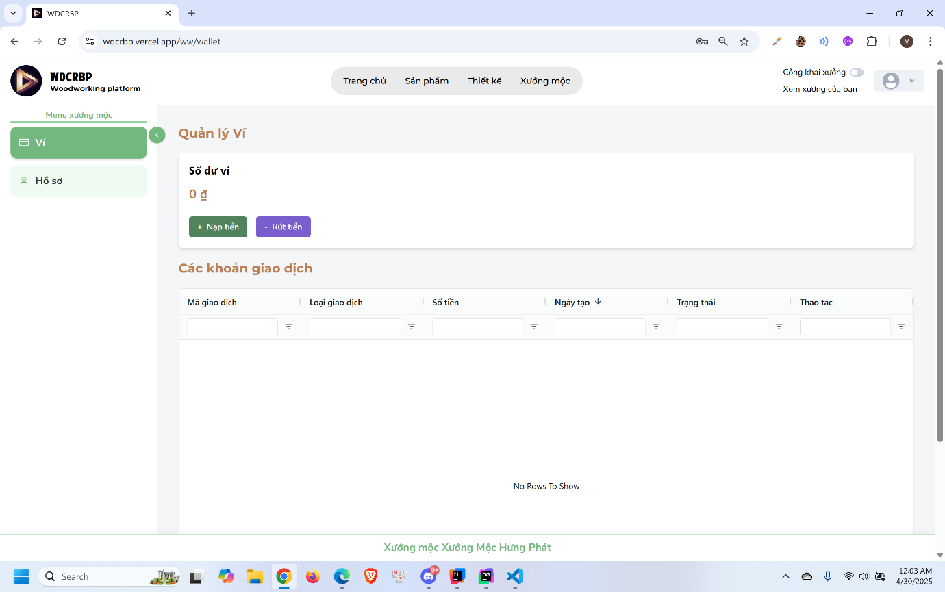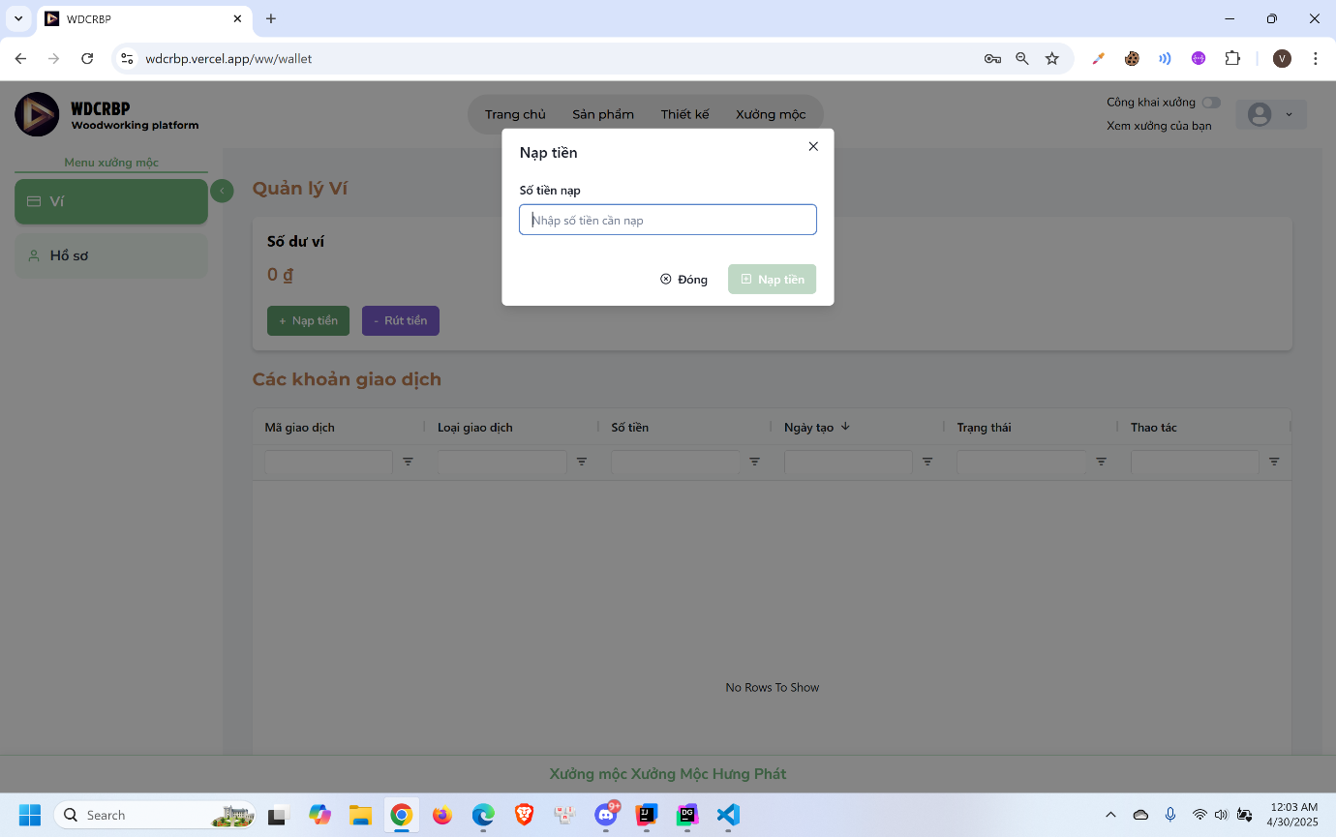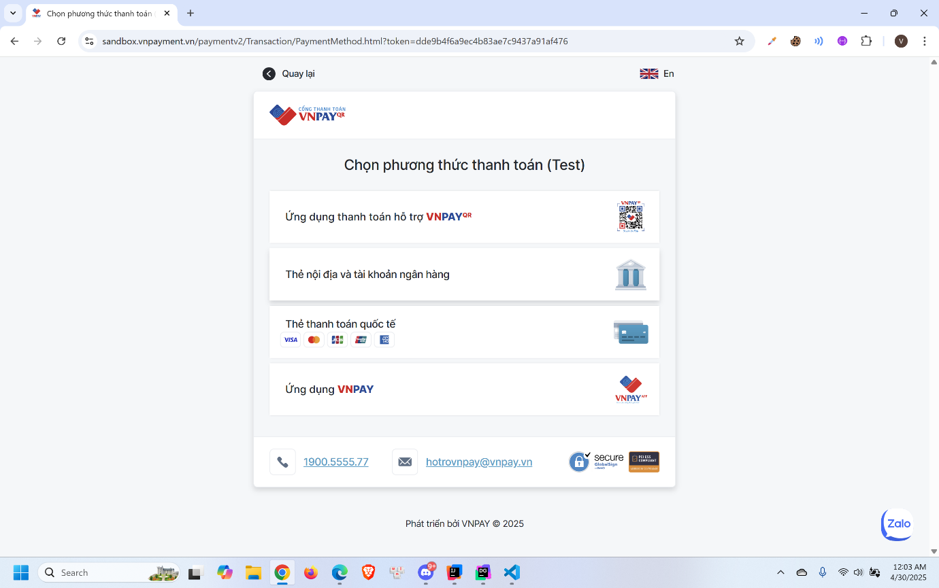
- Click “Nạp tiền”
- Enter amount and click “Nạp tiền”

3.2.1.4 Woodworker upgrade service pack
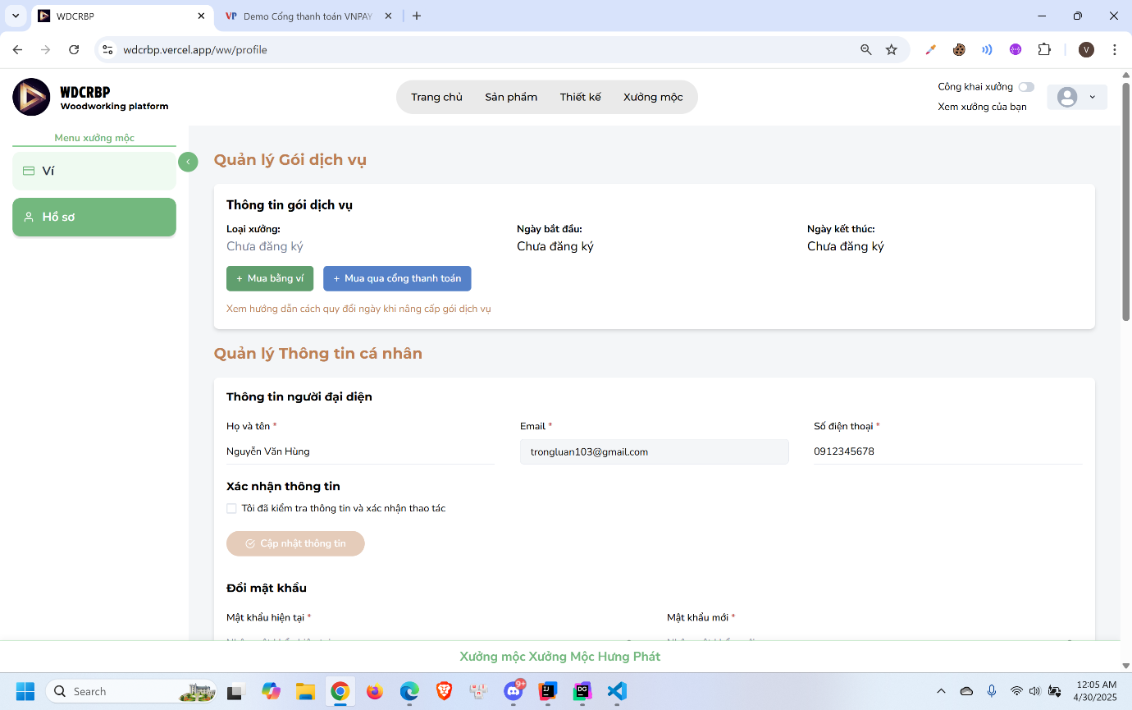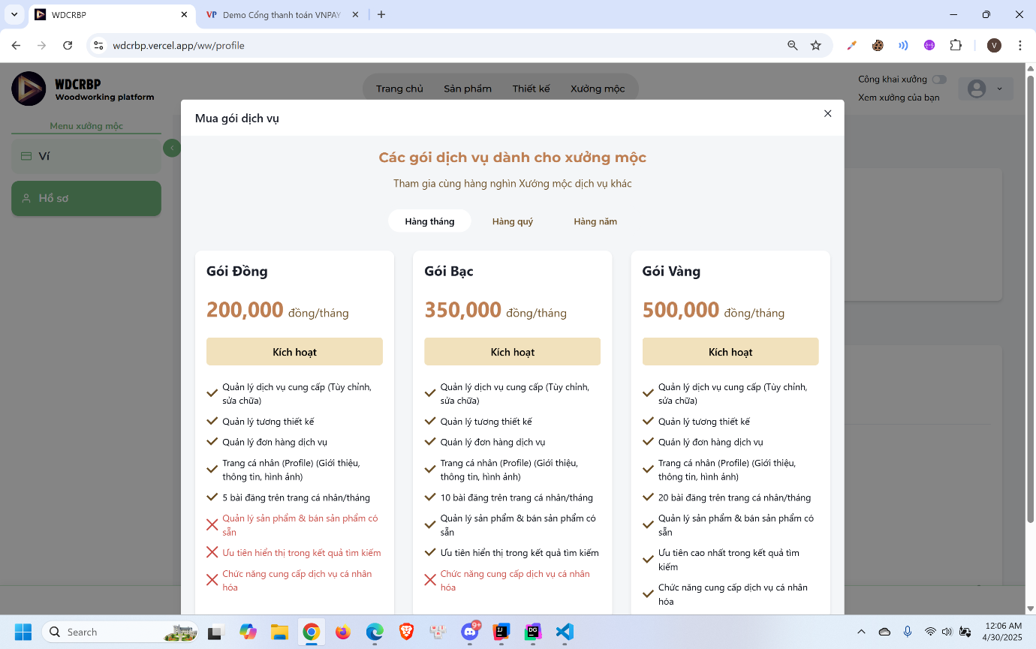
- Click “Mua bằng ví” or “Mua qua cổng thanh toán”
- Choose pack to use and click “Kích hoạt”

3.2.2 Customization Service Booking Feature

3.2.2.1 Customer request a customization order

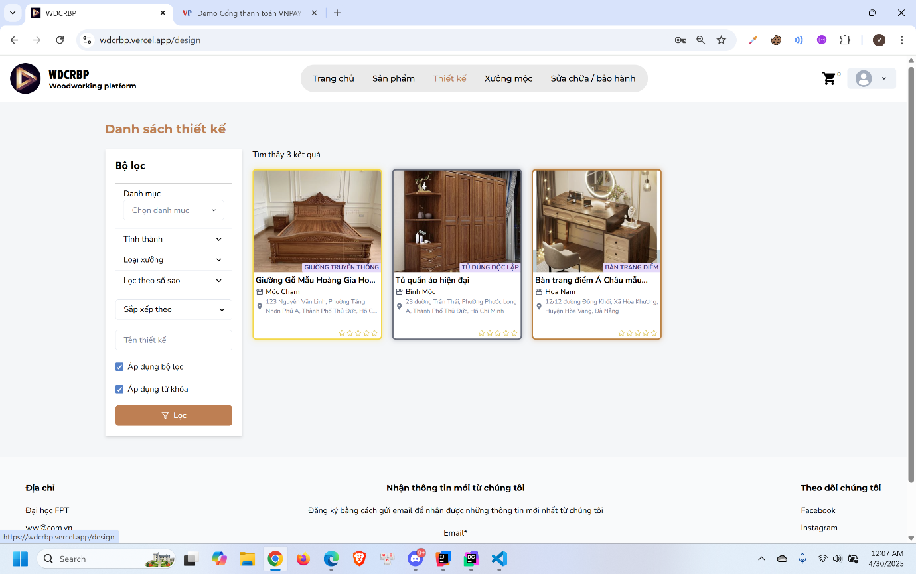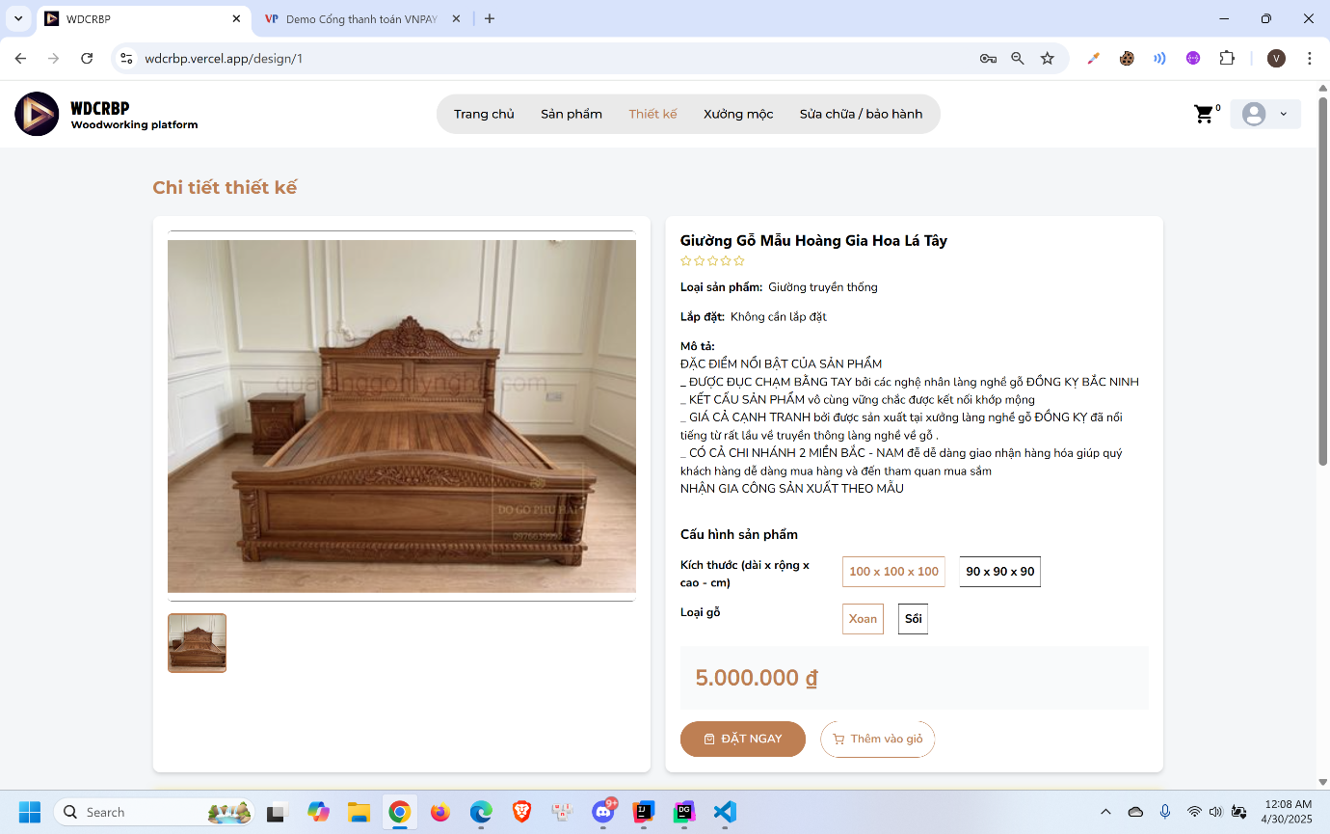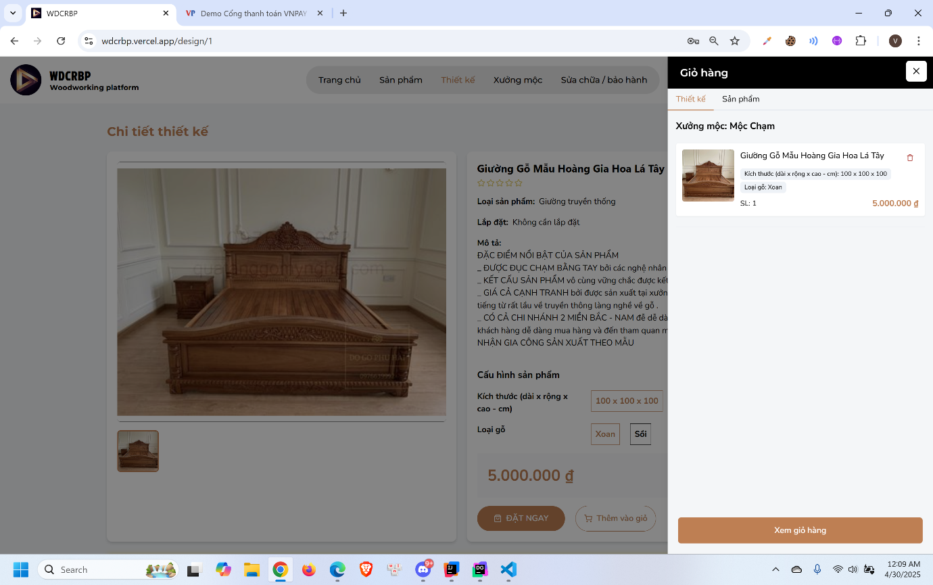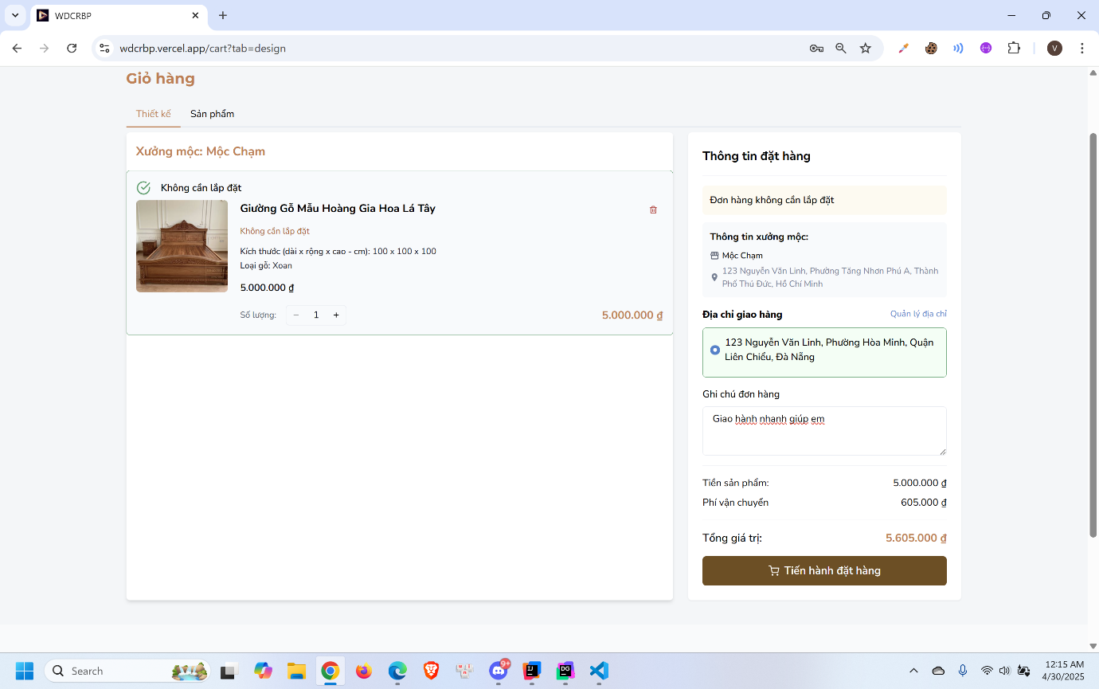
- Click “Thiết kế” in the header
- Select design to view detail
- Click “Thêm vào giỏ”
- Click cart icon in the header
- Click “Xem giỏ hàng”
- Fill in the form and click “Tiến hành đặt hàng”

3.2.2.2 Woodworker book a consultant appointment
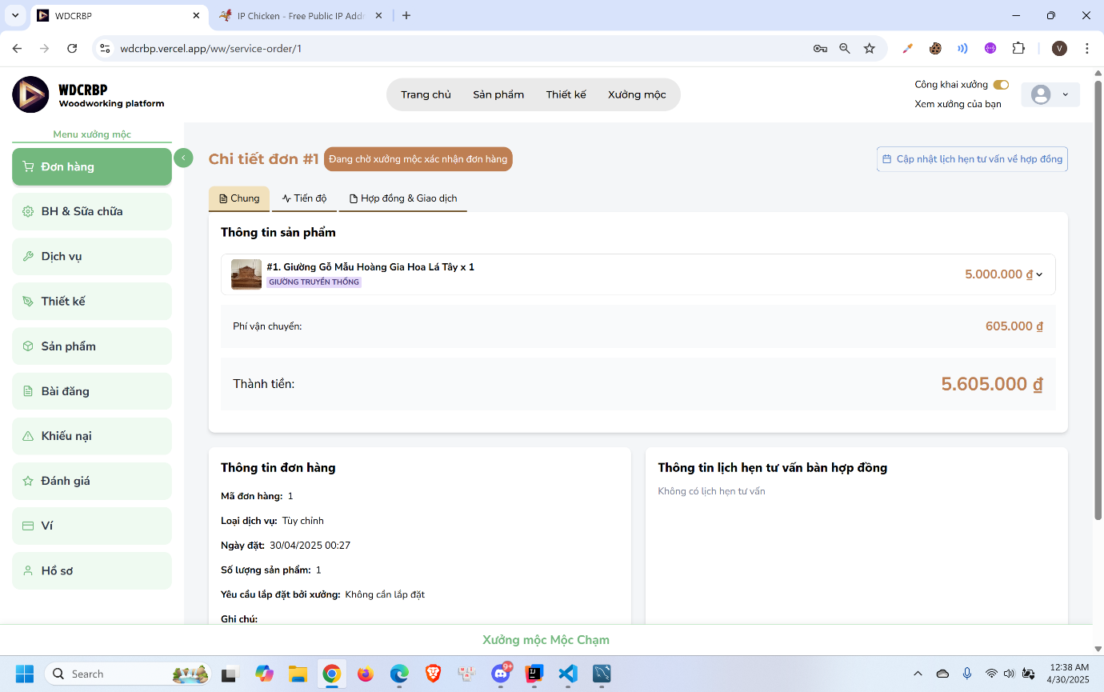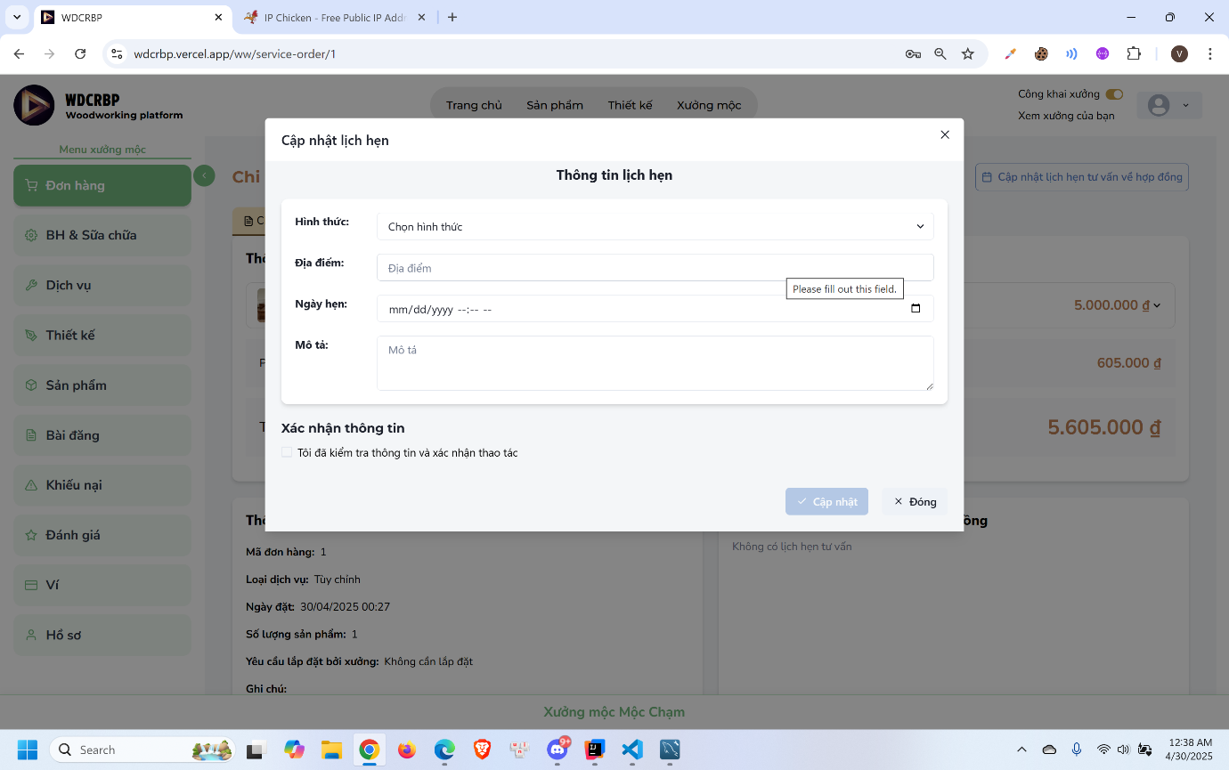
- Click “Cập nhật lịch hẹn tư vấn về hợp đồng”
- Enter the form and click “Cập nhật”

3.2.2.3 Customer confirm consultant appointment
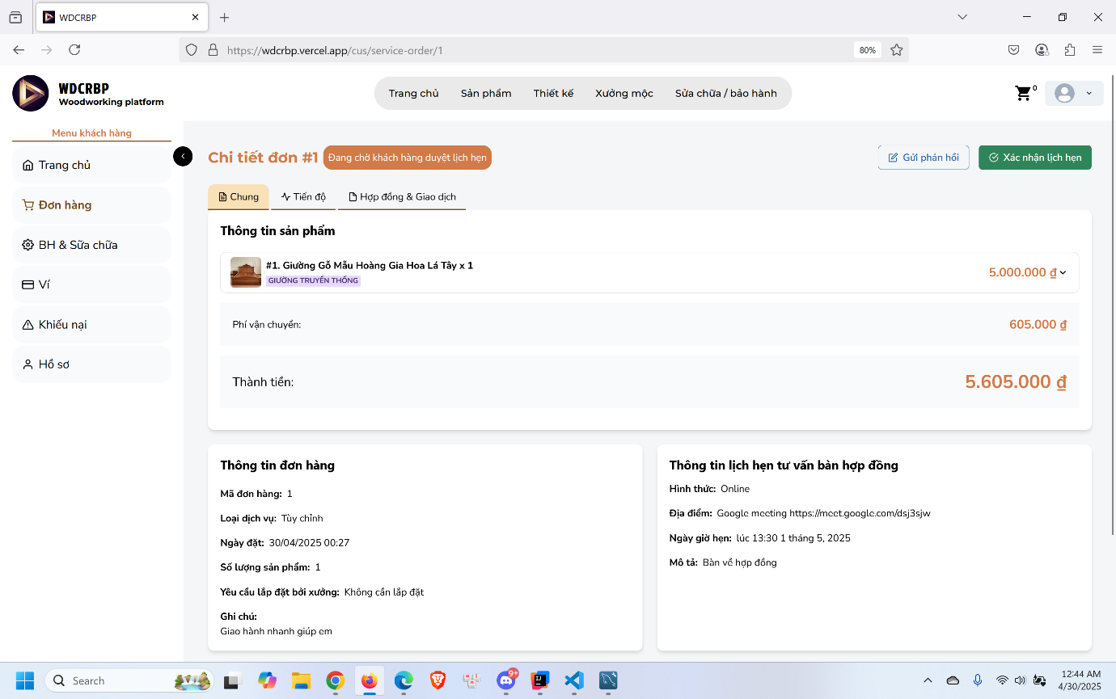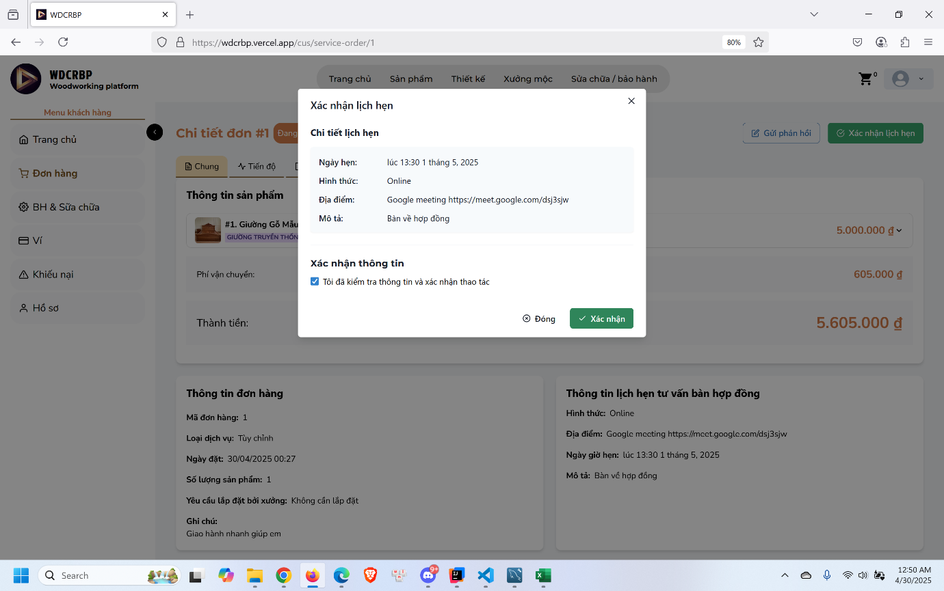
- Click “Xác nhận lịch hẹn”
- Click “Xác nhận”

3.2.2.4 Woodworker update the contract
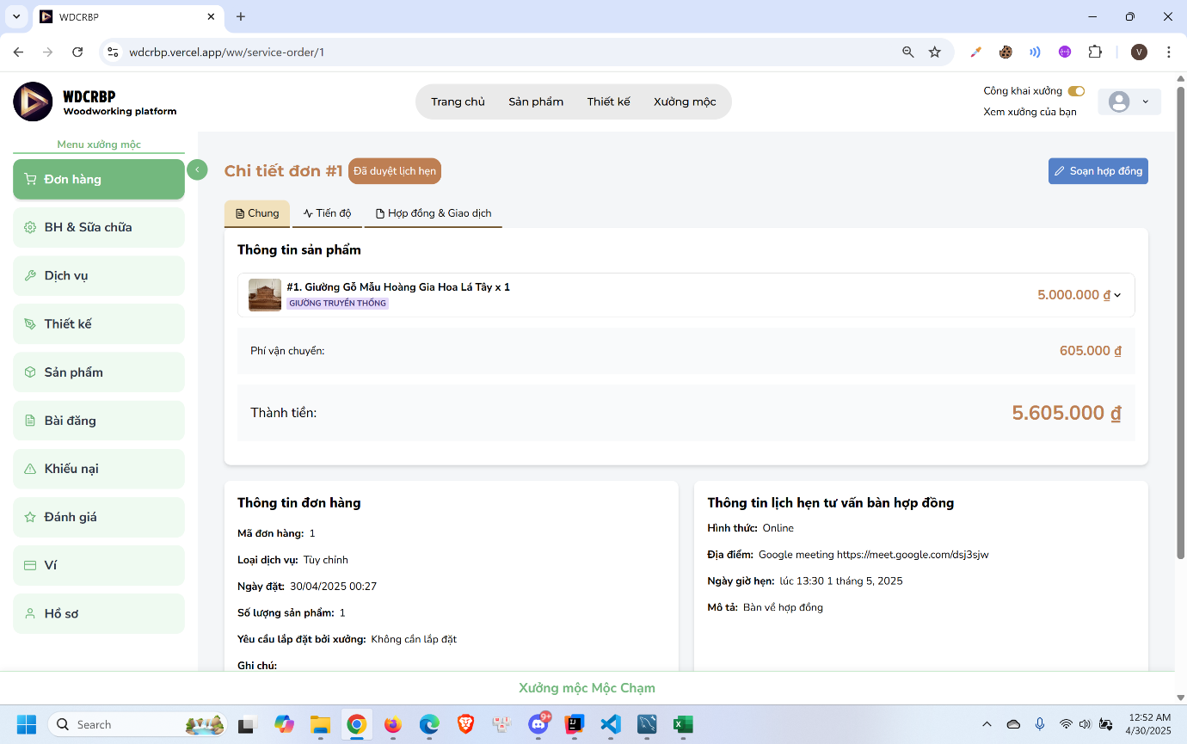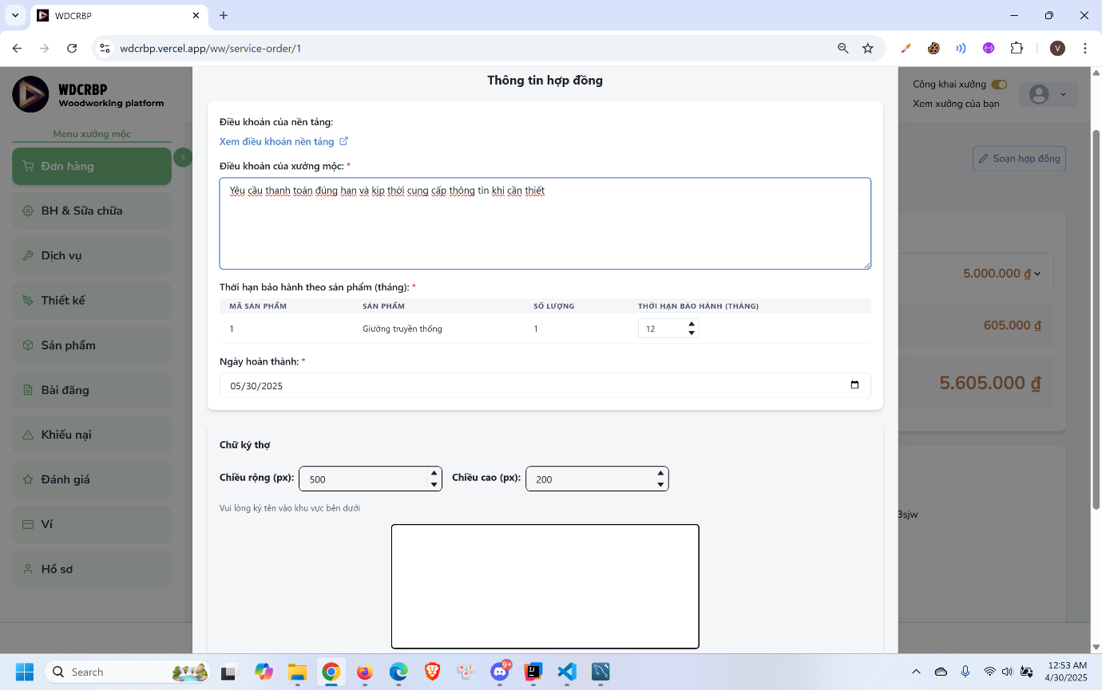
- Click “Soạn hợp đồng”
- Enter the form and sign in the box
- Click “Cập nhật”

3.2.2.5 Customer confirm contract and process payment
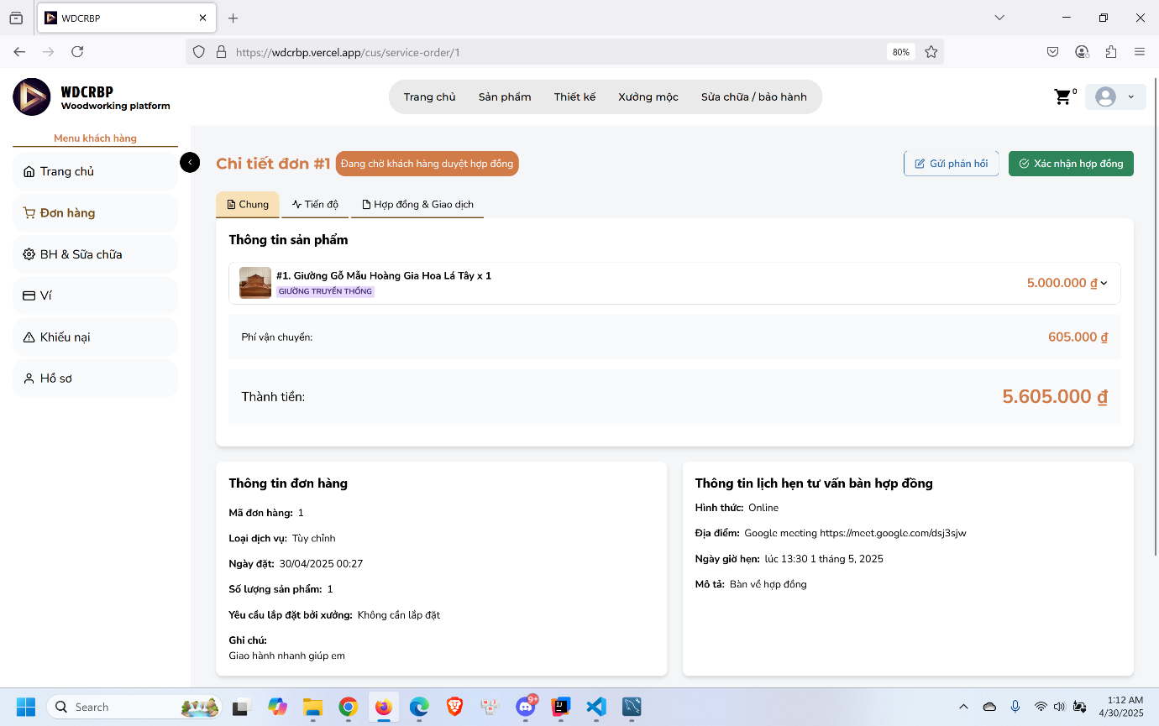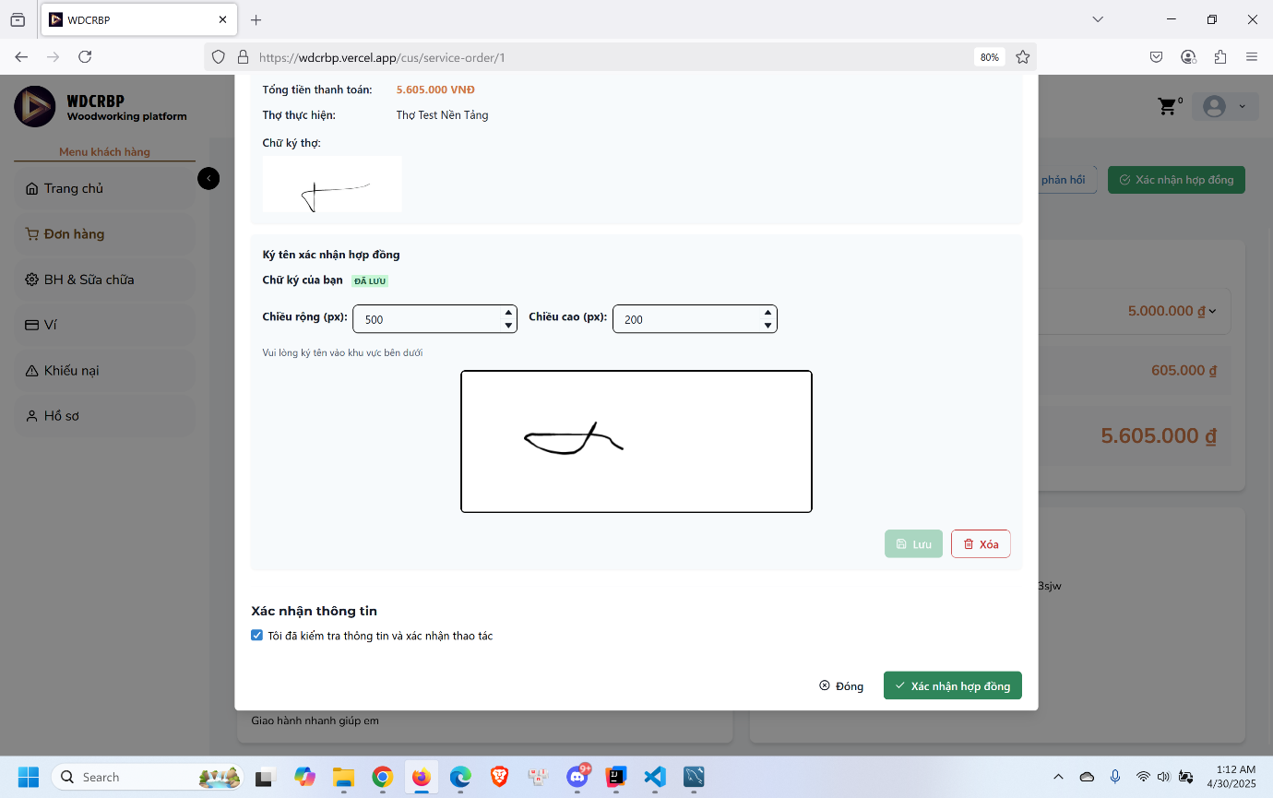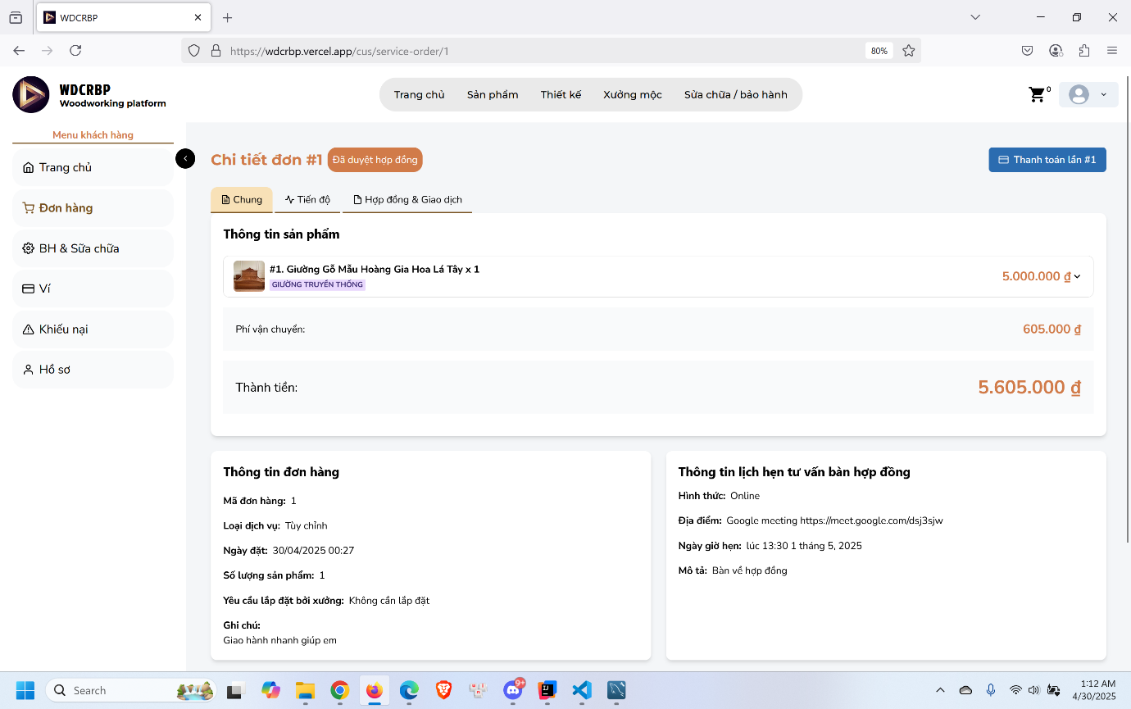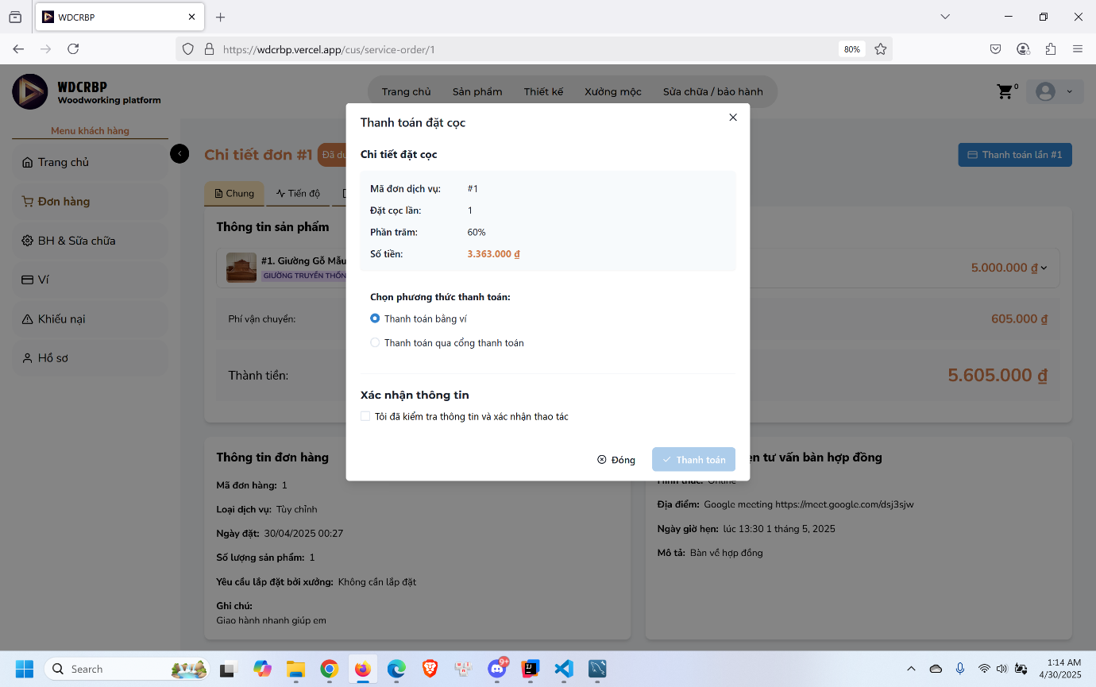
- Click “Xác nhận hợp đồng”
- Check information and sign in the box
- Click “Xác nhận hợp đồng”
- Click “Thanh toán”
- Choose payment method and process payment

3.2.2.6 Woodworker upload the finish product image
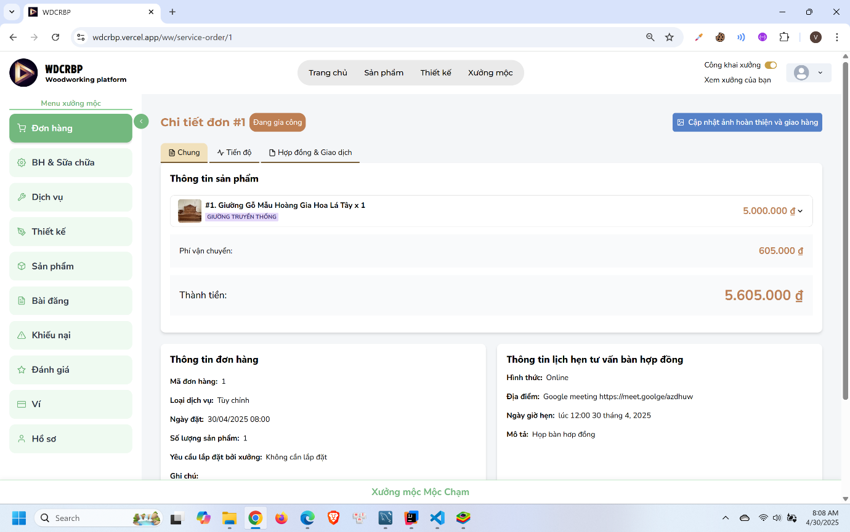
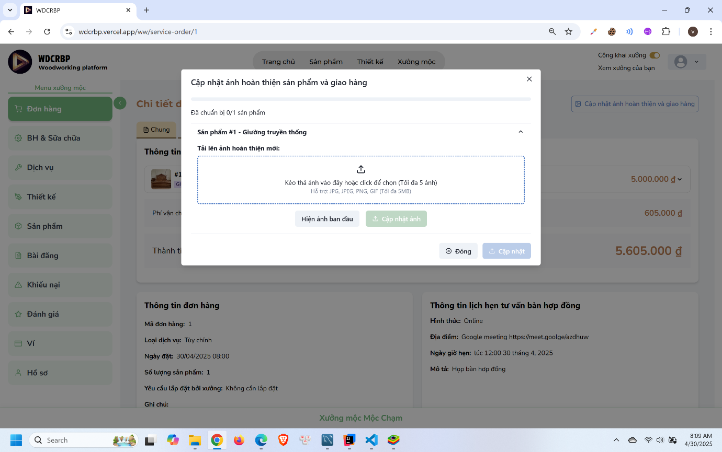
- Click “Cập nhật ảnh hoàn thiện và giao hàng”
- Upload images and click “Cập nhật”

3.2.2.7 Customer confirm receive product and process payment
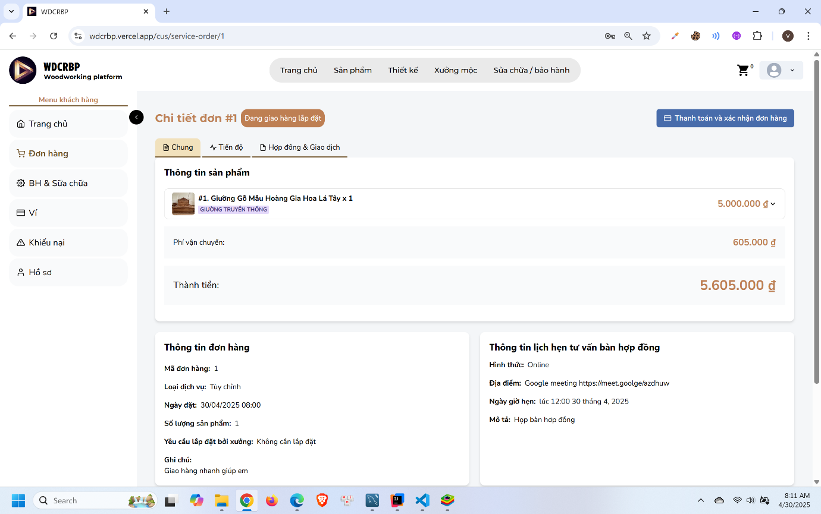
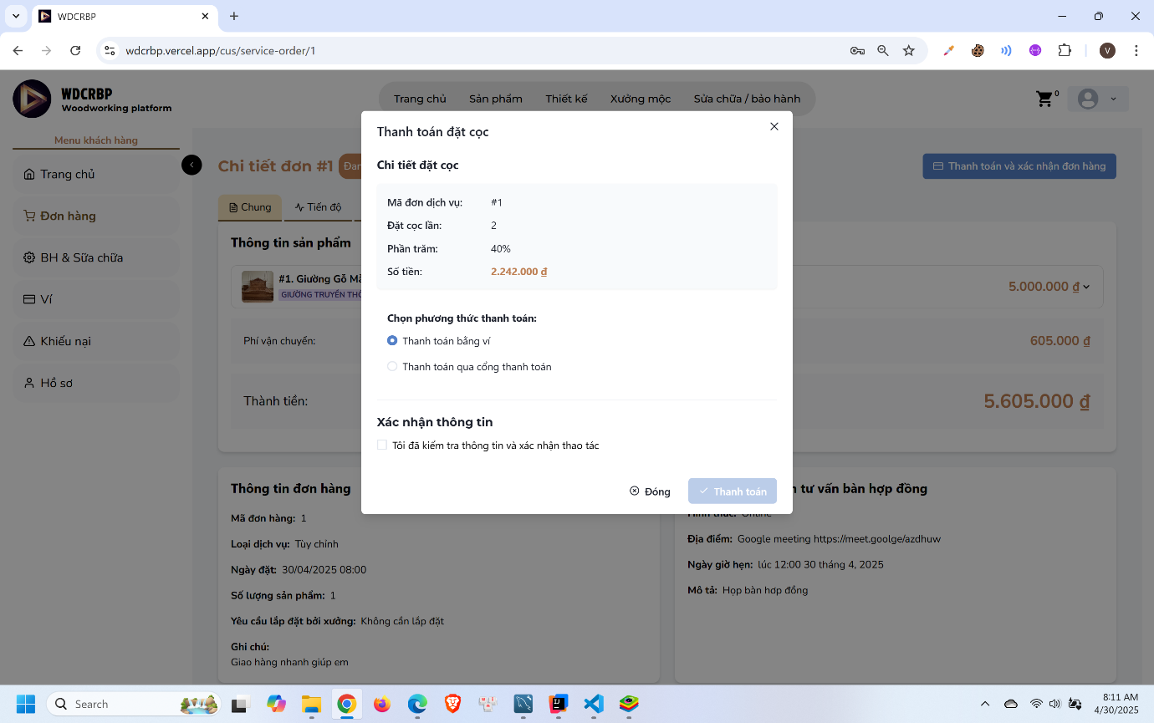
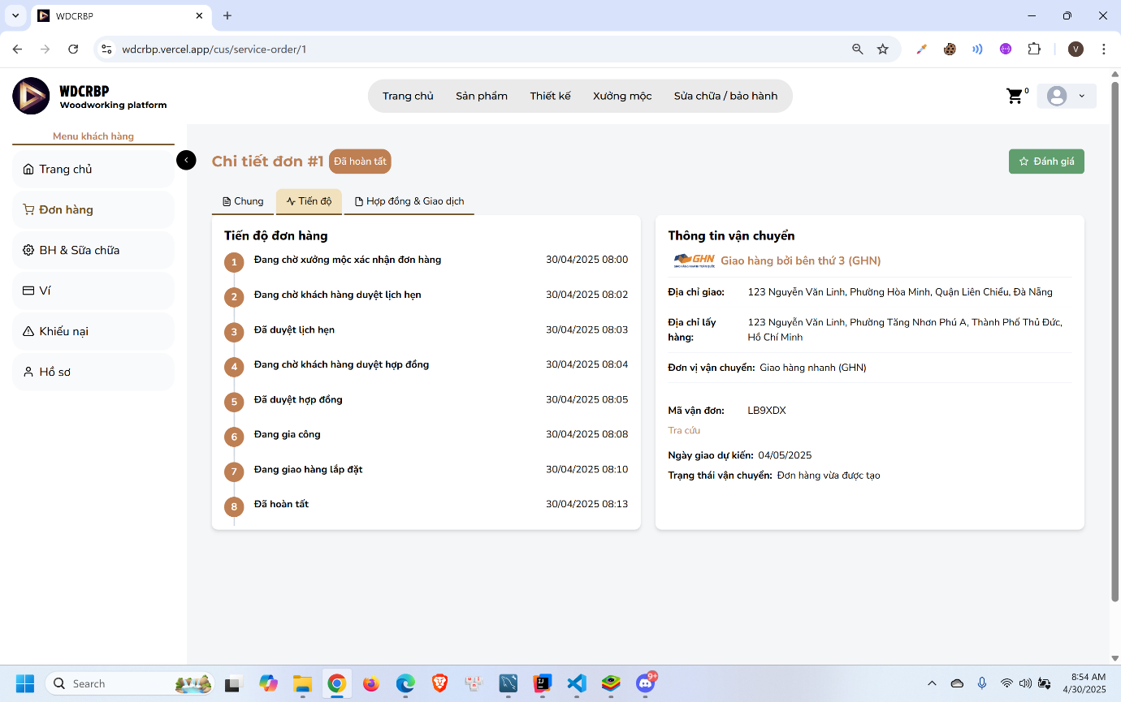
- Click “Thanh toán và xác nhận đơn hàng”
- Choose payment method and process payment

3.2.3 Guarantee Service Booking Feature

3.2.3.1 Customer request a guarantee order
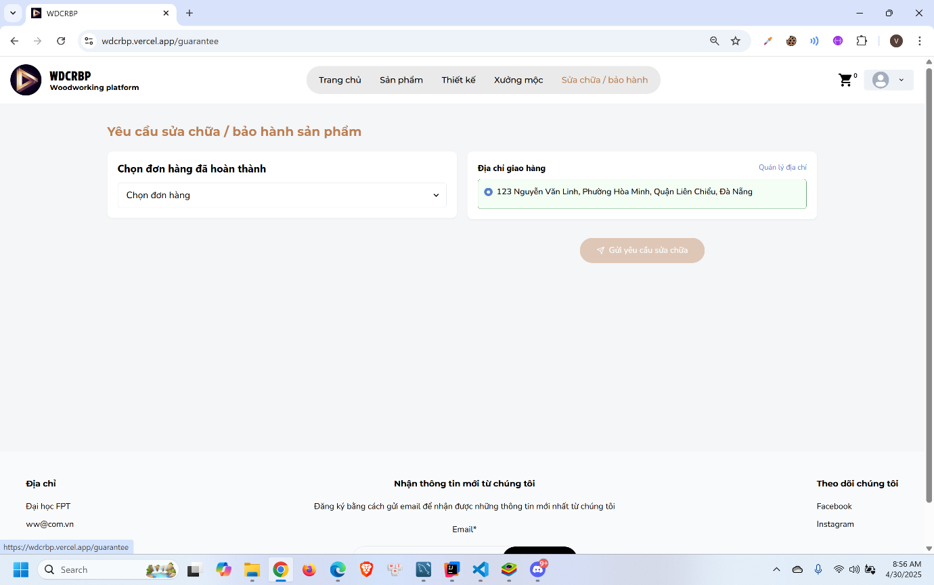
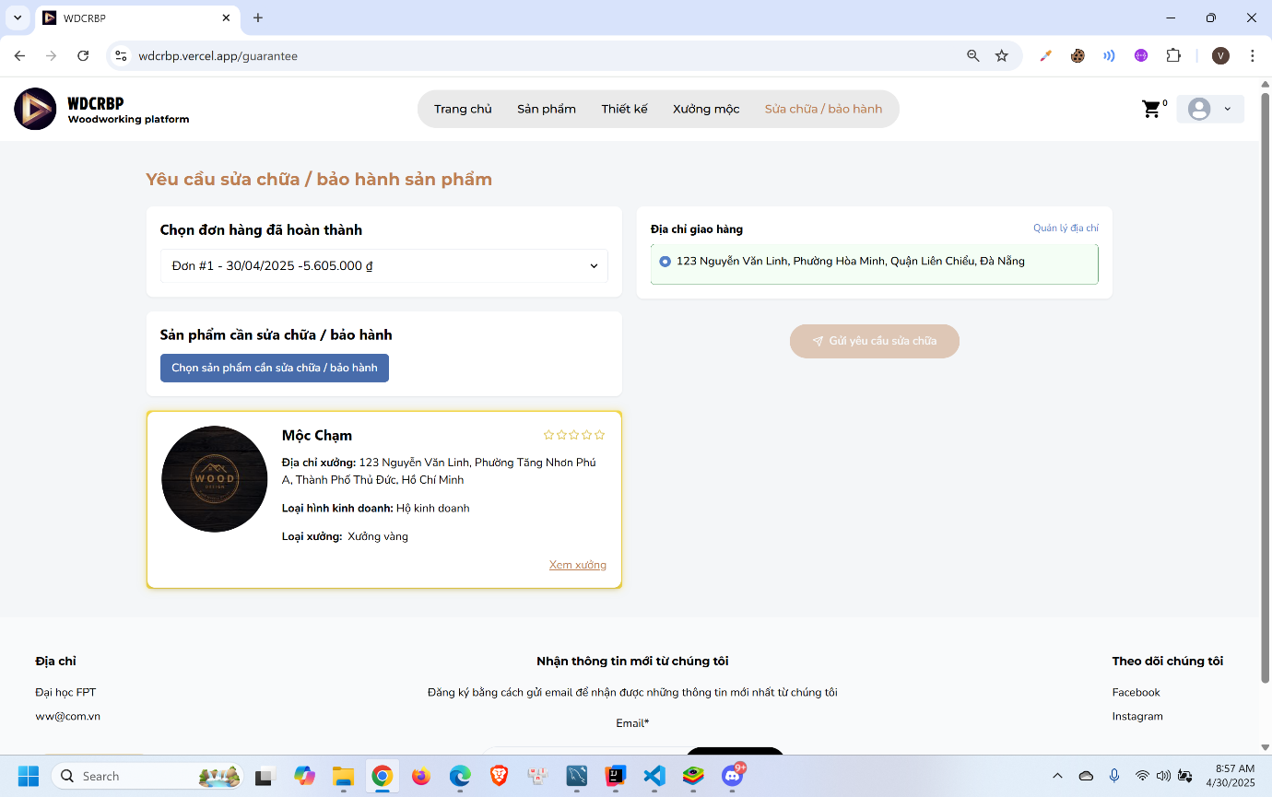
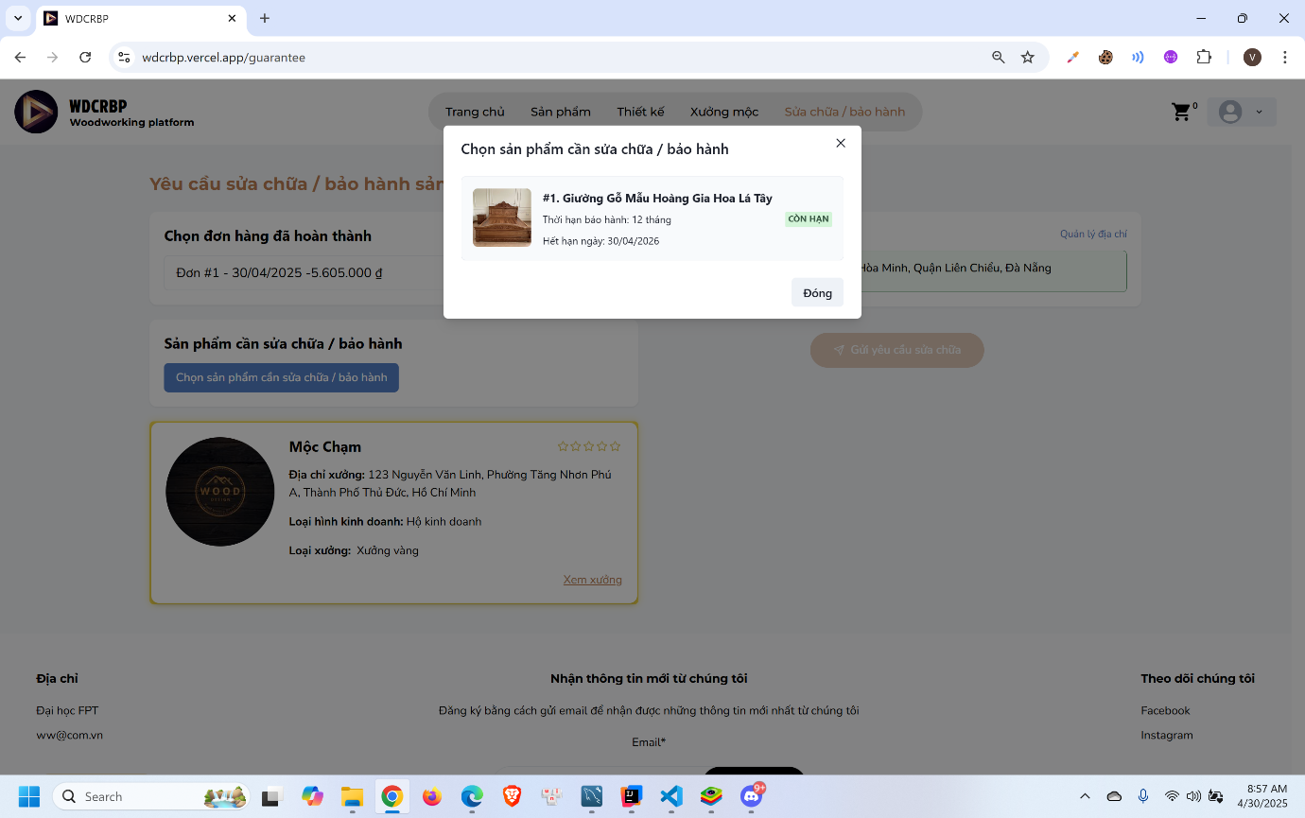
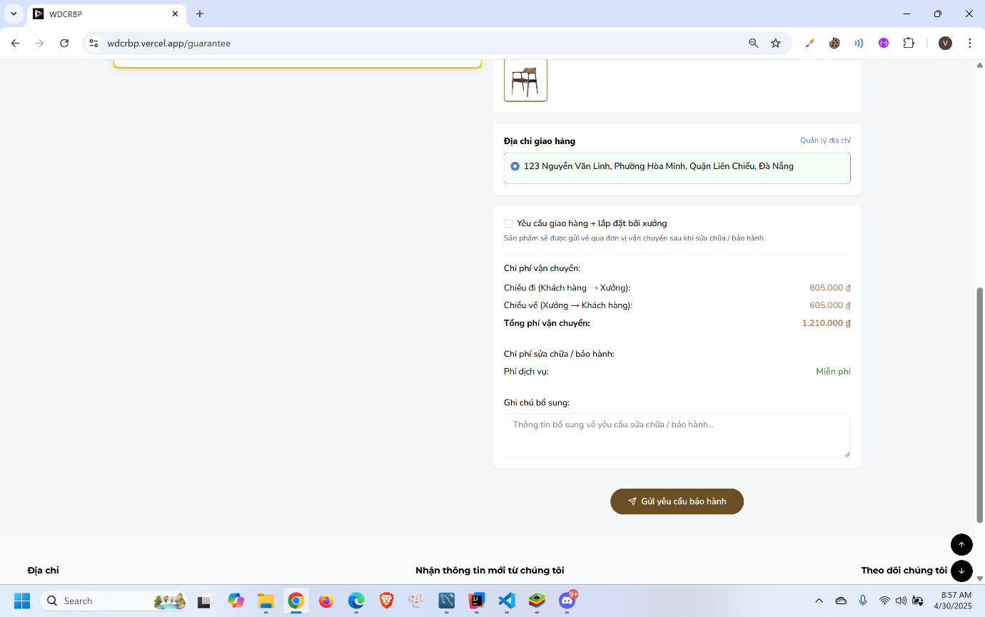
- Click “Sửa chữa / bảo hành” in the menu
- Select order to request
- Select product to request
- Fill in the form and click “Gửi yêu cầu bảo hành”

3.2.3.2 Woodworker accept the guarantee order
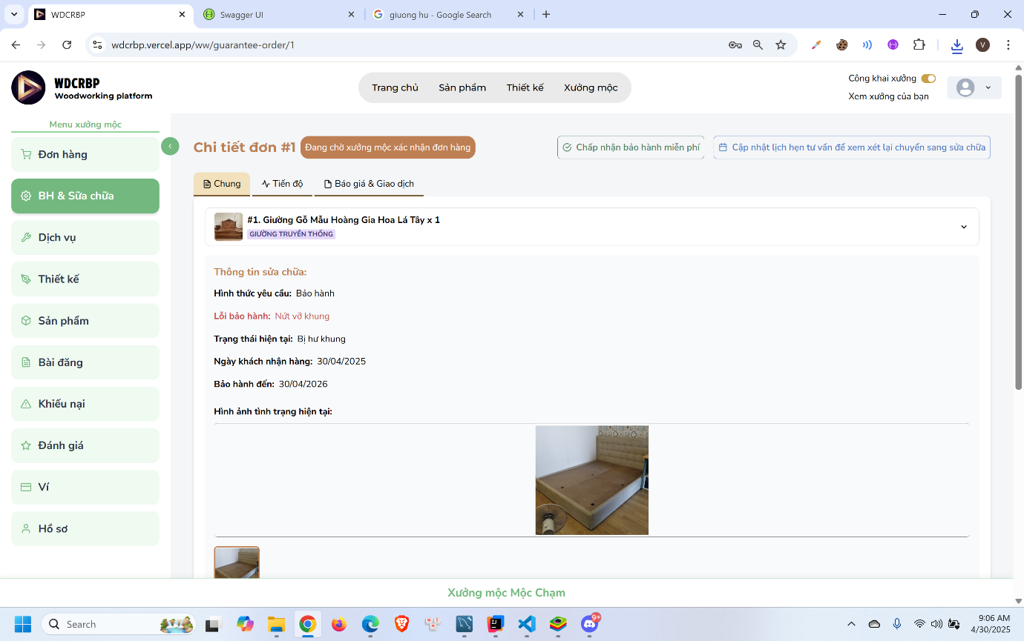
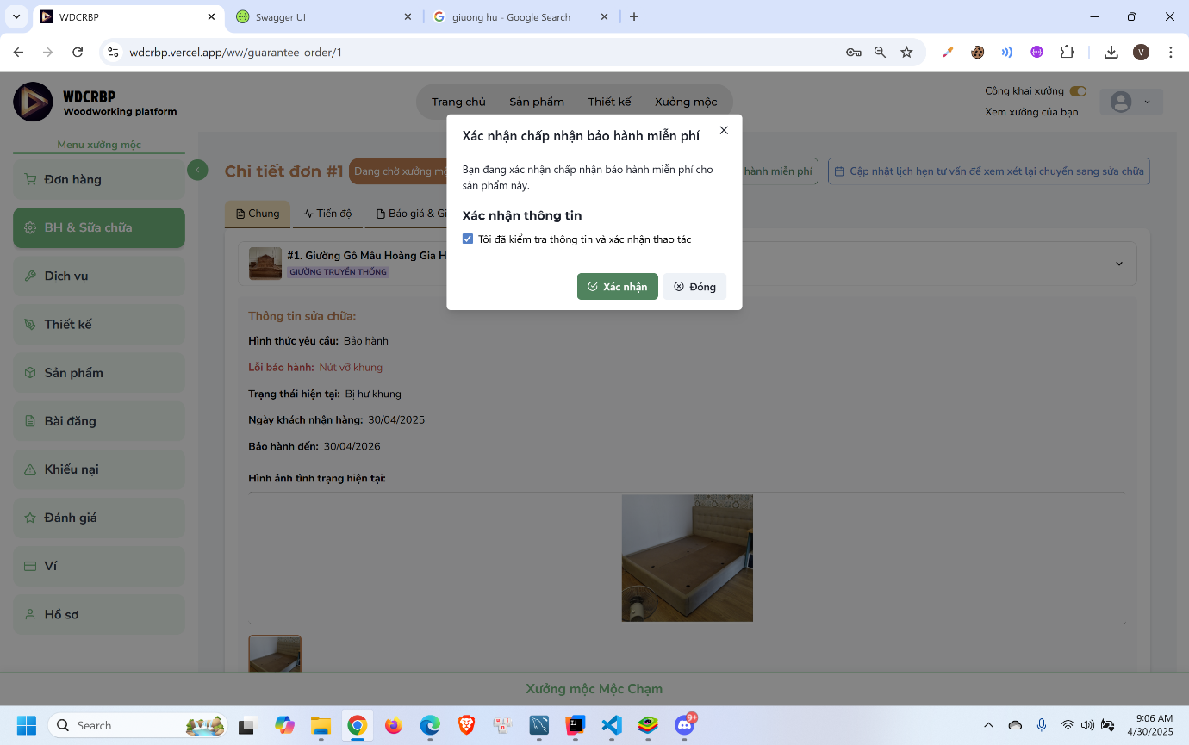
- Click “Chấp nhận bảo hành miễn phí”
- Click “Xác nhận”

3.2.3.3 Woodworker confirm receive product
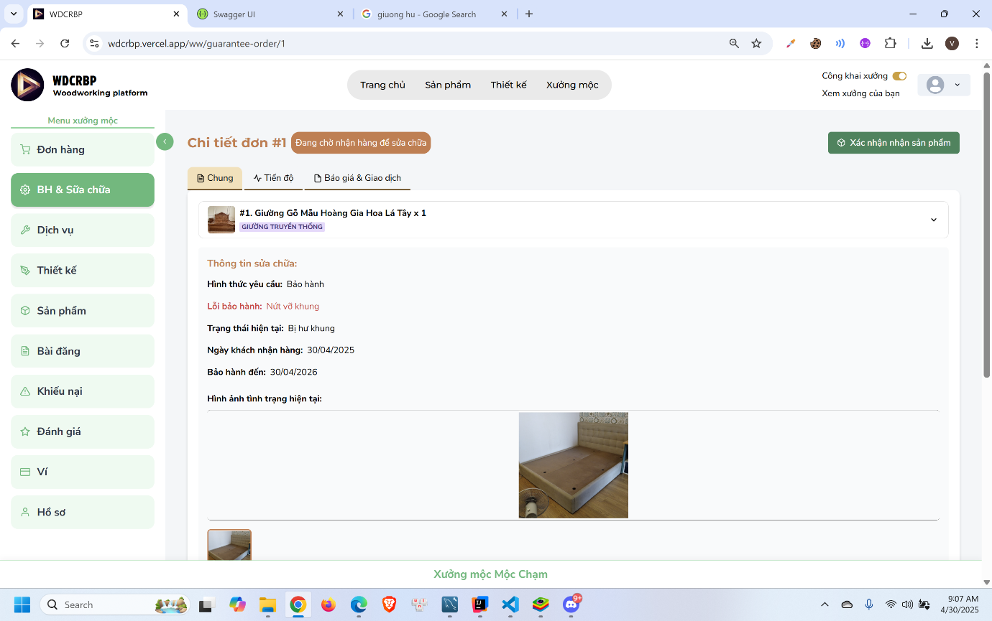
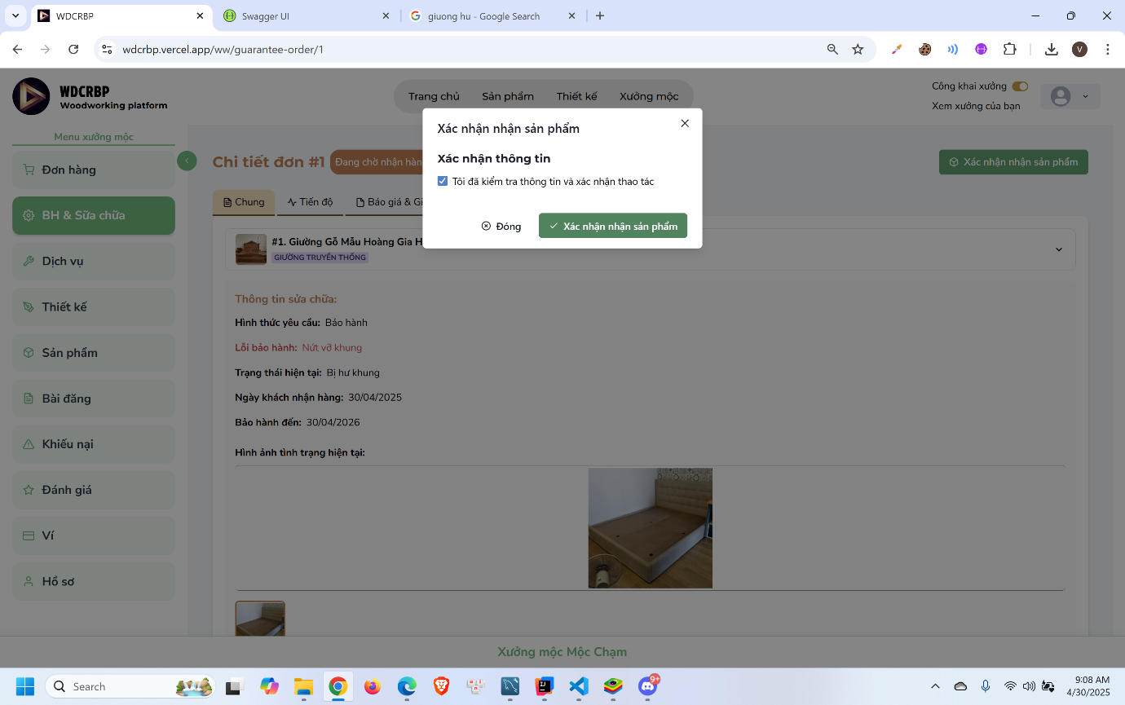
- Click “Xác nhận nhận sản phẩm”
- Click “Xác nhận”

3.2.3.4 Woodworker confirm repair finish
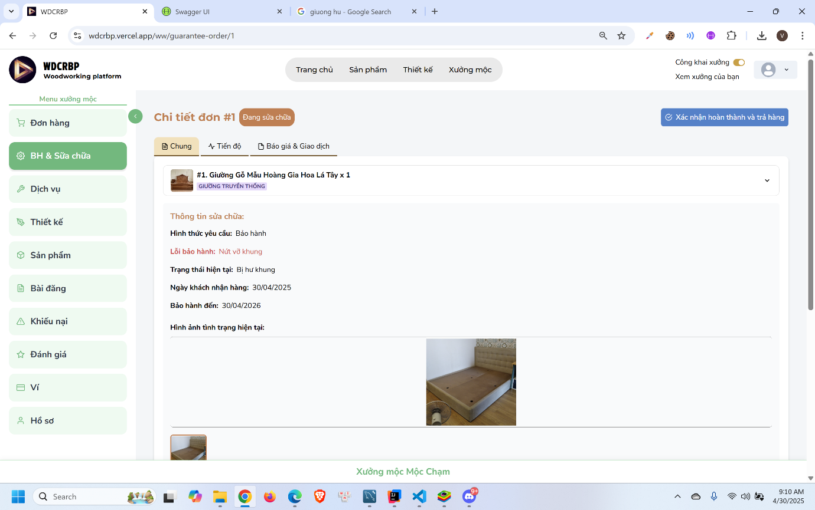

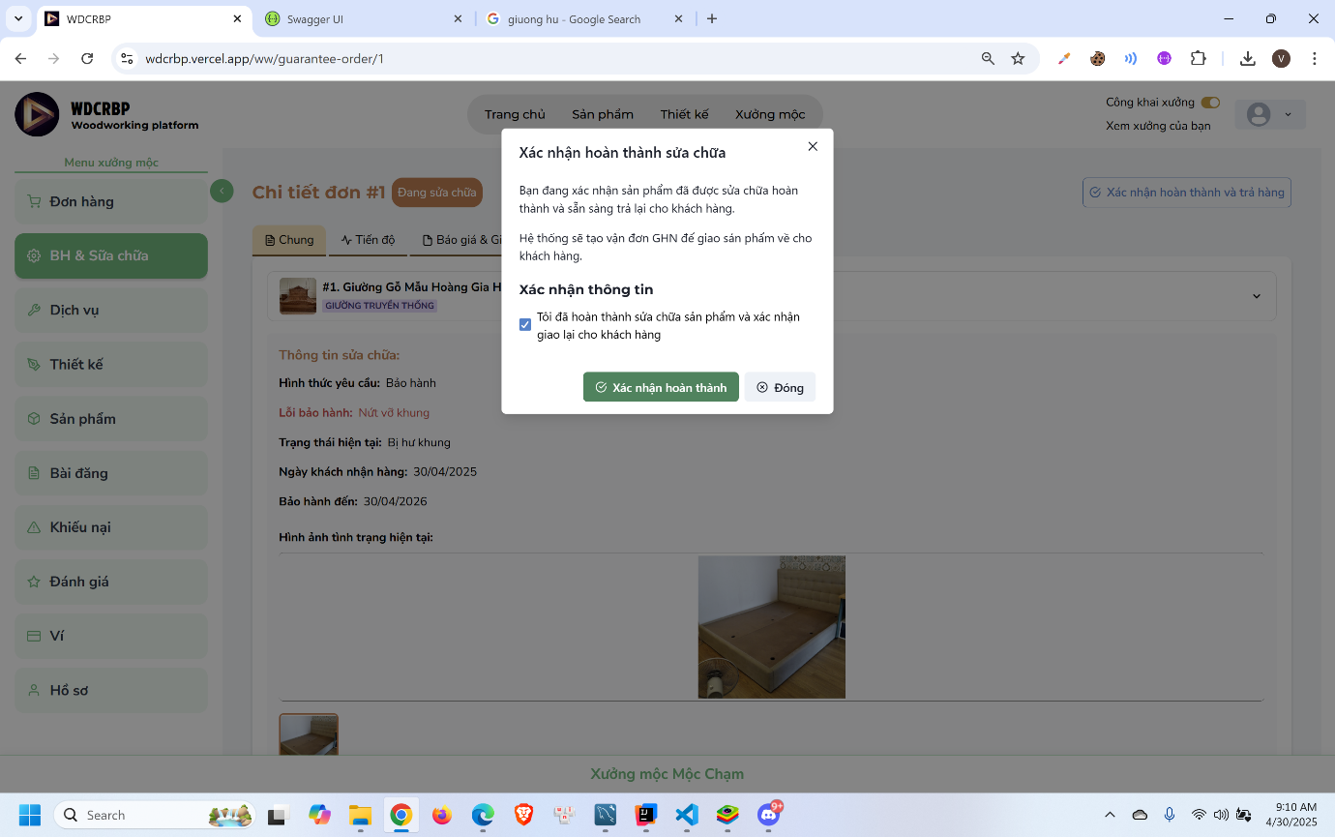
- Click “Xác nhận hoàn thành và trả hàng”
- Click “Xác nhận hoàn thành”

3.2.3.5 Customer confirm receive product and process payment
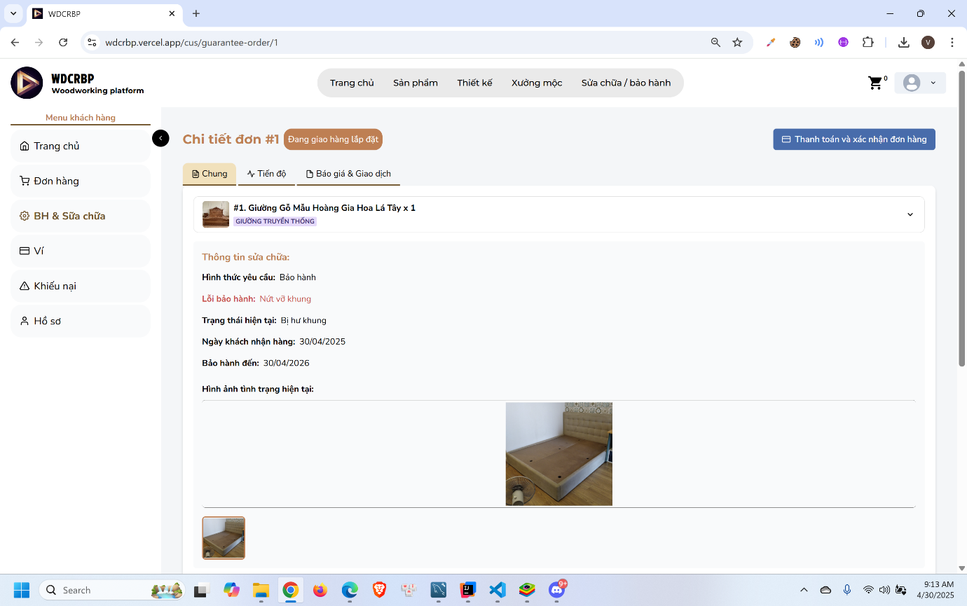
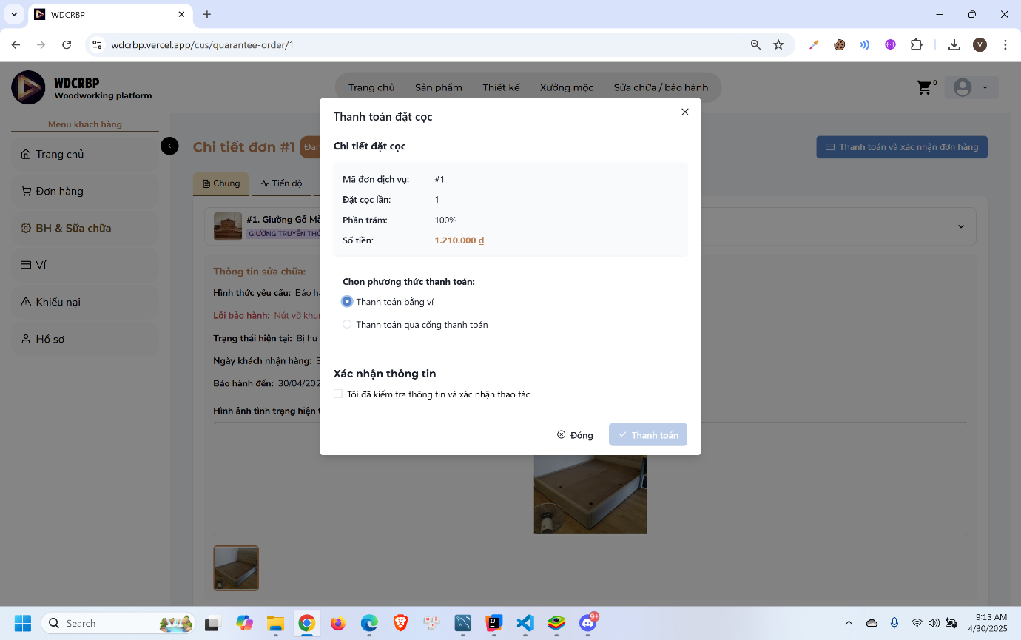
- Click “Thanh toán và xác nhận đơn hàng”
- Choose payment method and process payment

3.3 Mobile application

3.3.1 Woodworker Registration Feature

3.3.1.1 Guest register as a woodworker
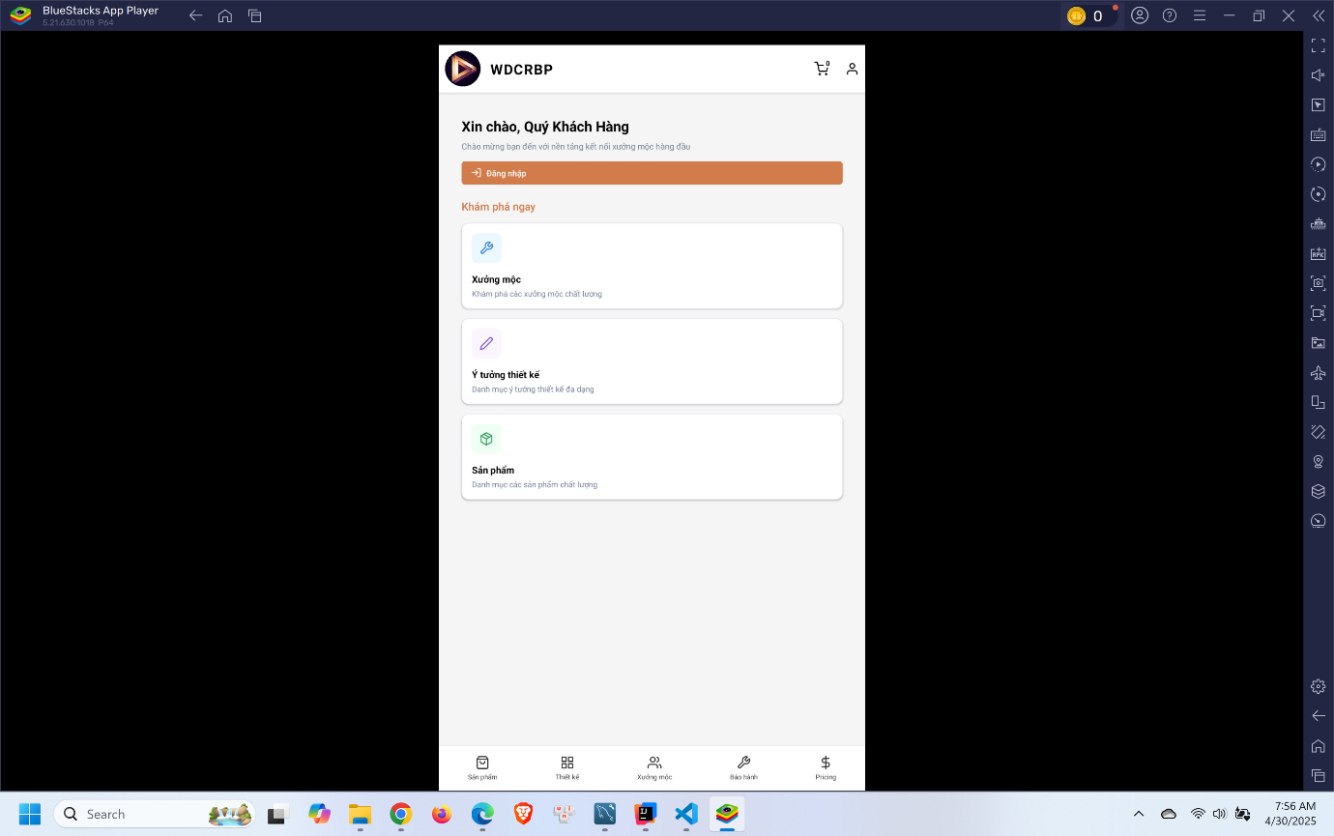
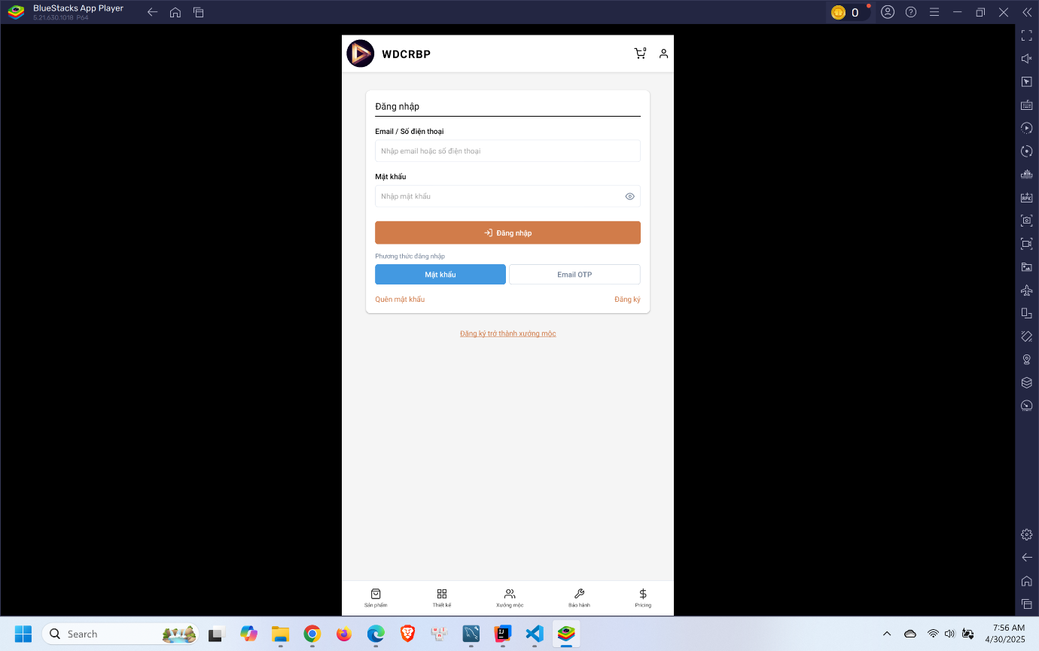
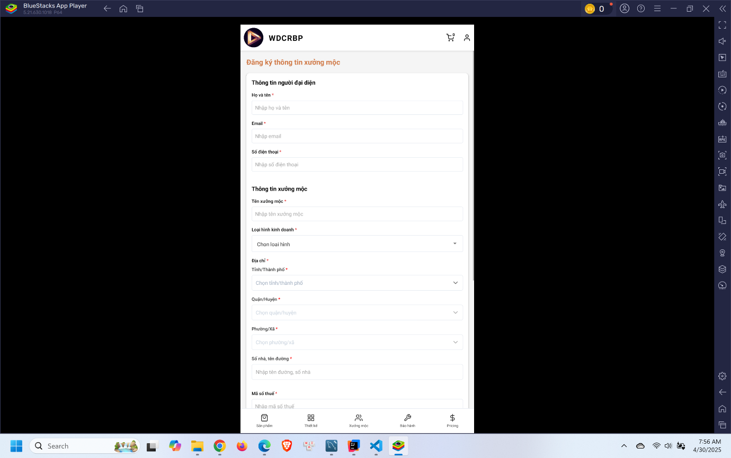
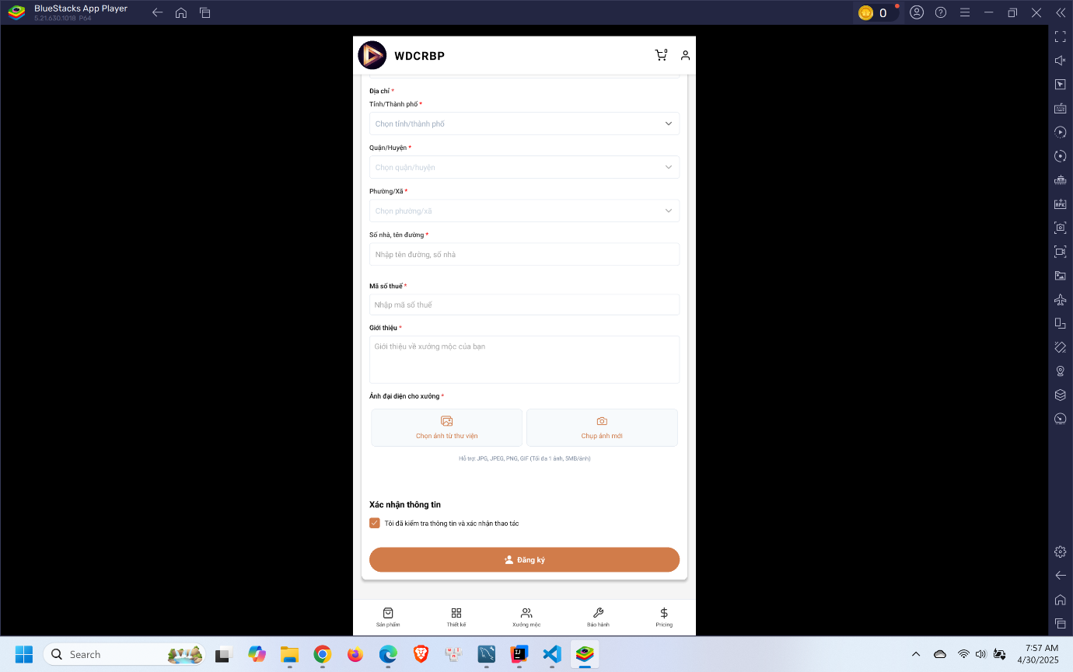
- Click account incon in the header
- Click “Đăng ký trở thành xưởng mộc”
- Fill in the registration form
- Click “Đăng ký”

3.3.1.2 Woodworker deposit money to wallet
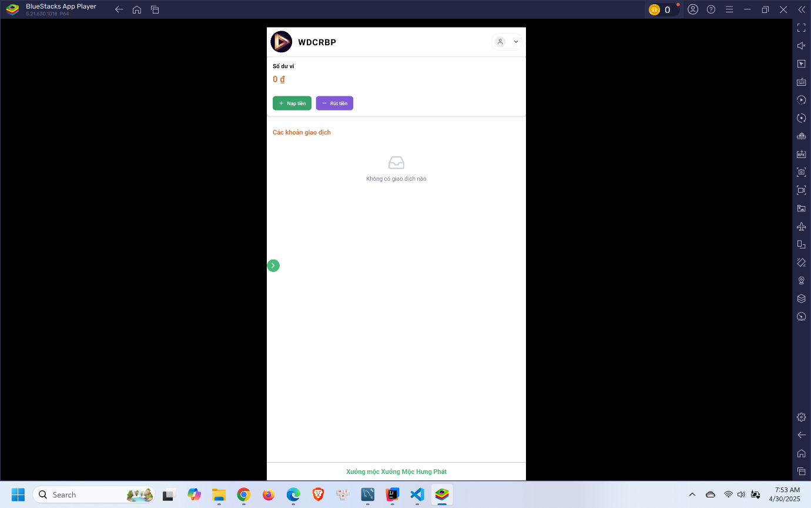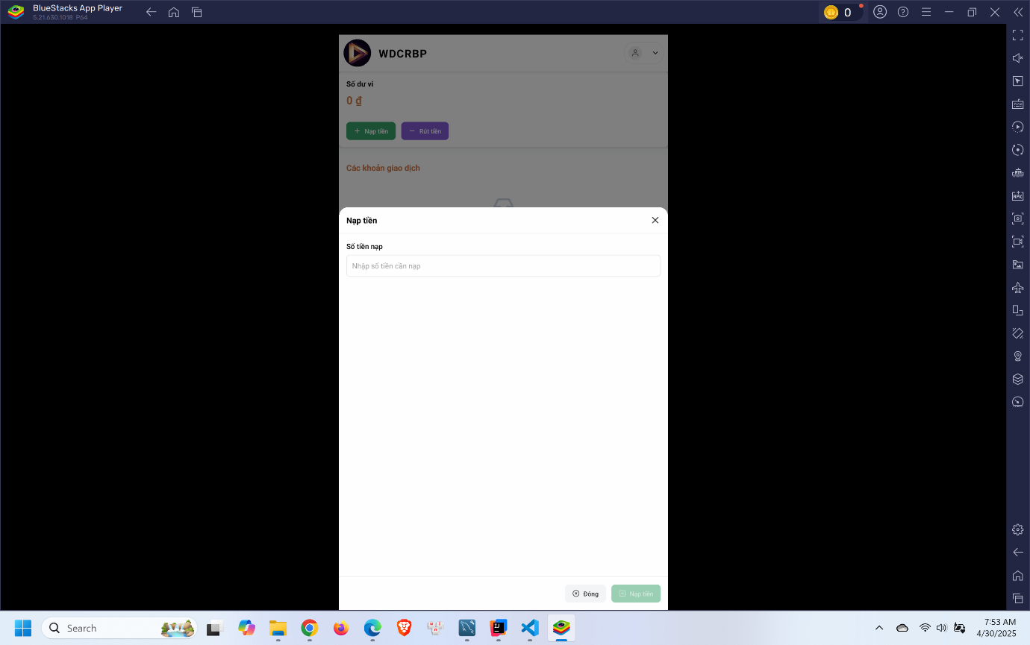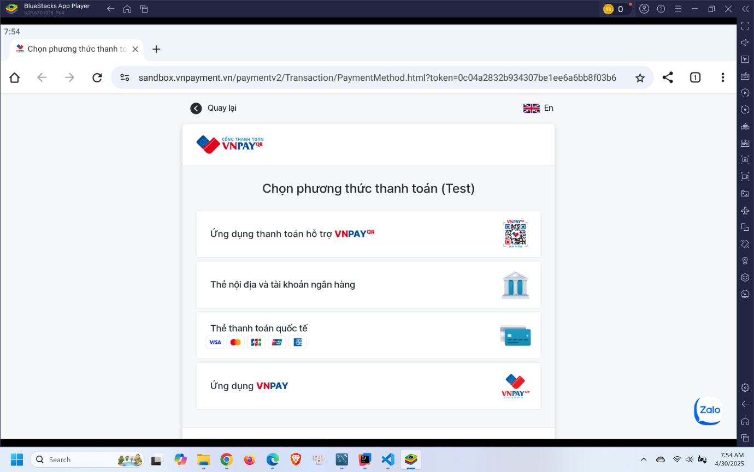
- Click “Nạp tiền”
- Enter amount and click “Nạp tiền”

3.3.1.3 Woodworker upgrade service pack
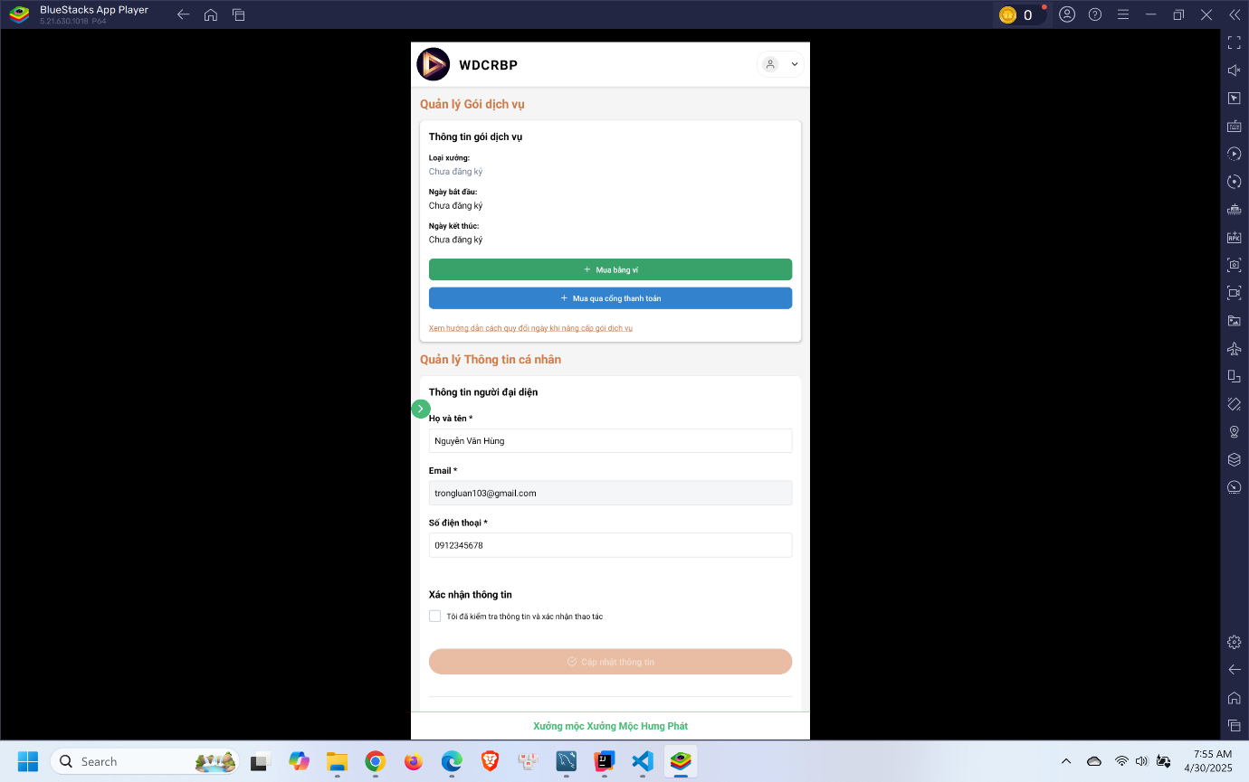
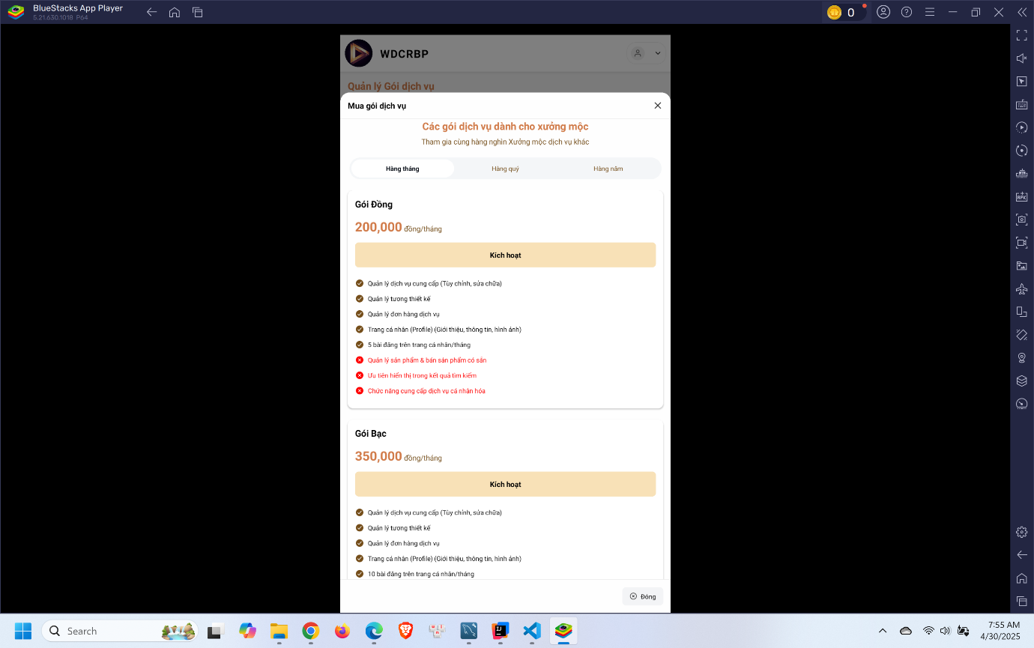
- Click “Mua bằng ví” or “Mua qua cổng thanh toán”
- Choose pack to use and click “Kích hoạt”

3.3.2 Customization Service Booking Feature

3.3.2.1 Customer request a customization order
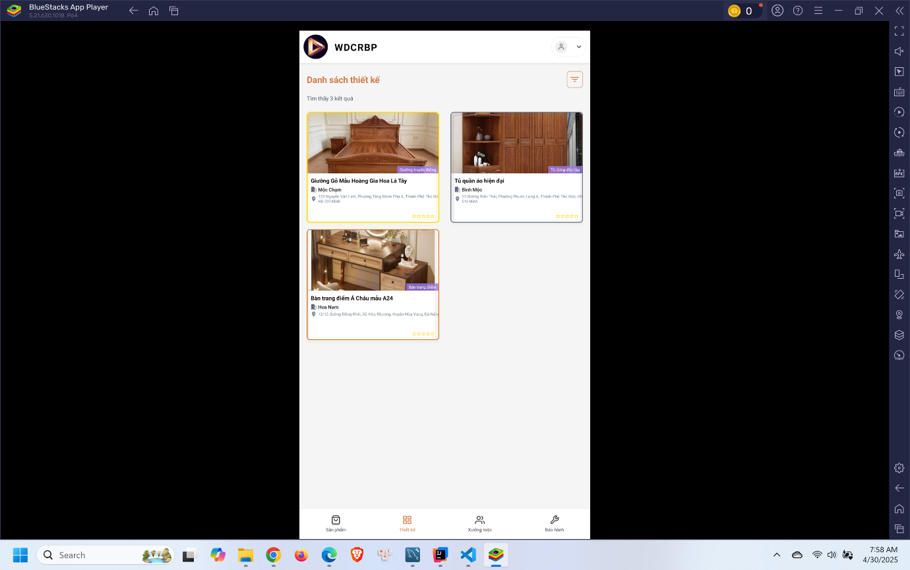
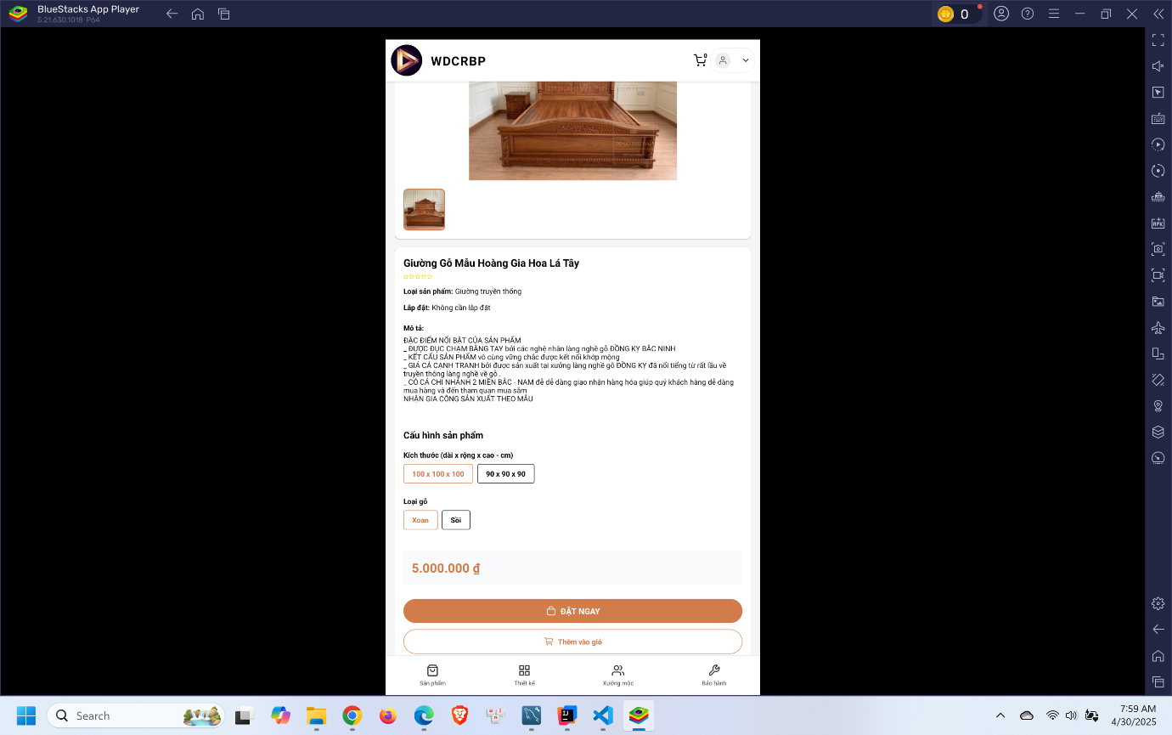
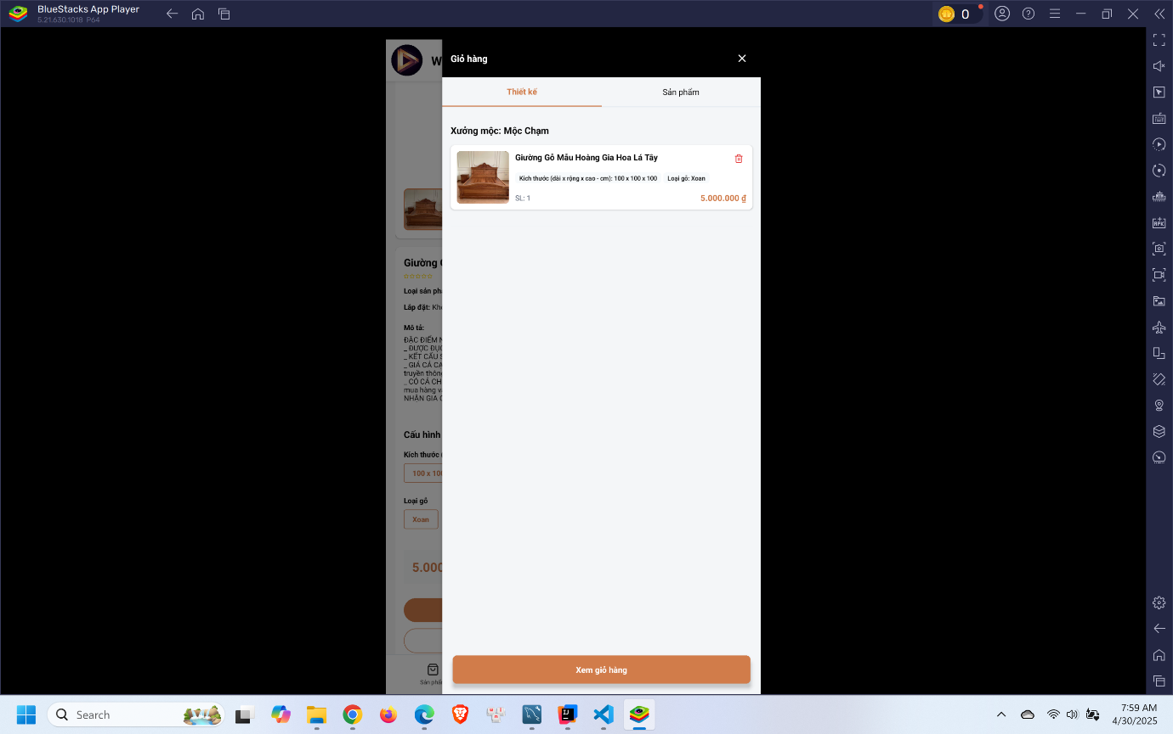
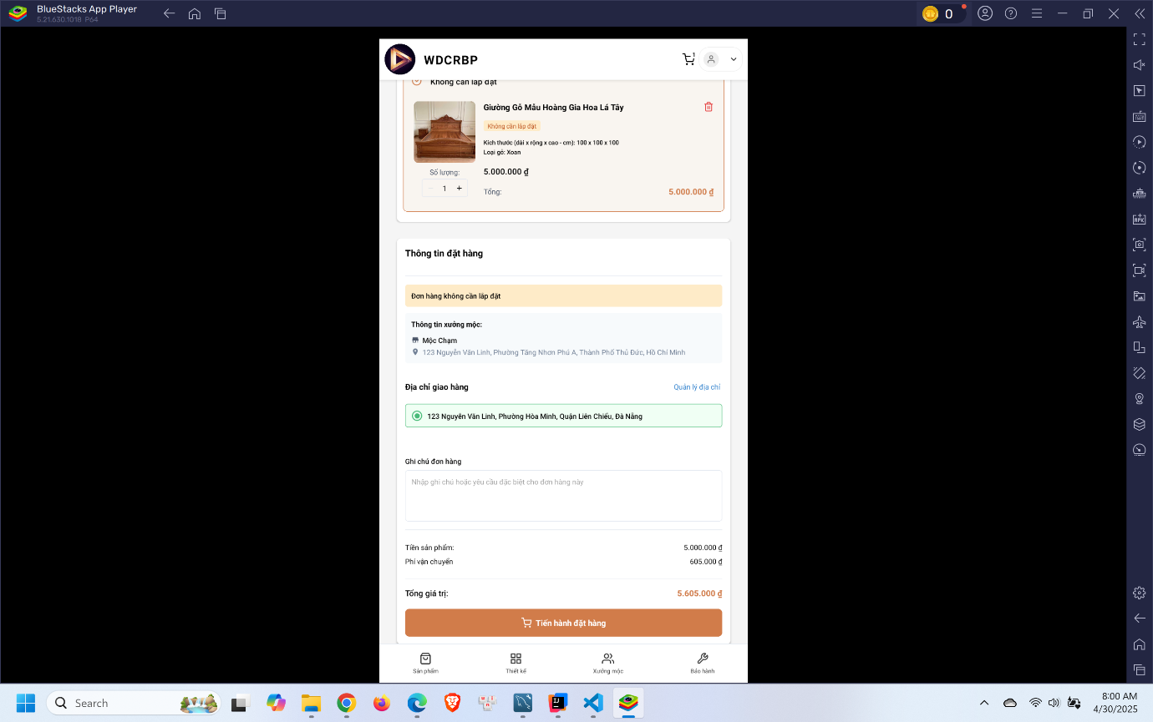
- Click “Thiết kế” in the menu
- Select design to view detail
- Click “Thêm vào giỏ”
- Click cart icon in the header
- Click “Xem giỏ hàng”
- Fill in the form and click “Tiến hành đặt hàng”

3.3.2.2 Woodworker book a consultant appointment
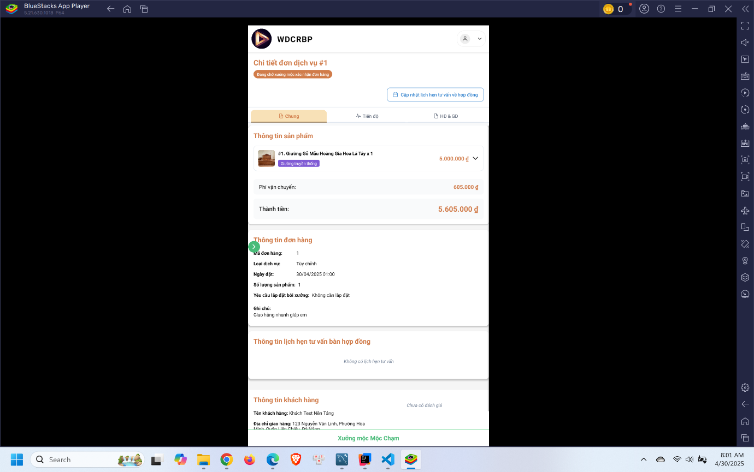
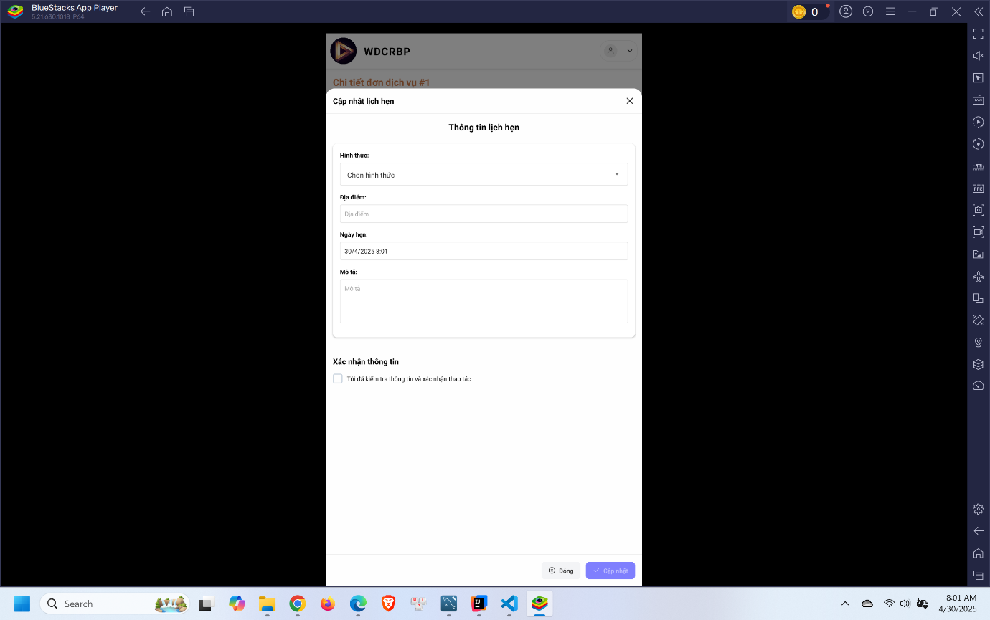
- Click “Cập nhật lịch hẹn tư vấn về hợp đồng”
- Enter the form and click “Cập nhật”

3.3.2.3 Customer confirm consultant appointment
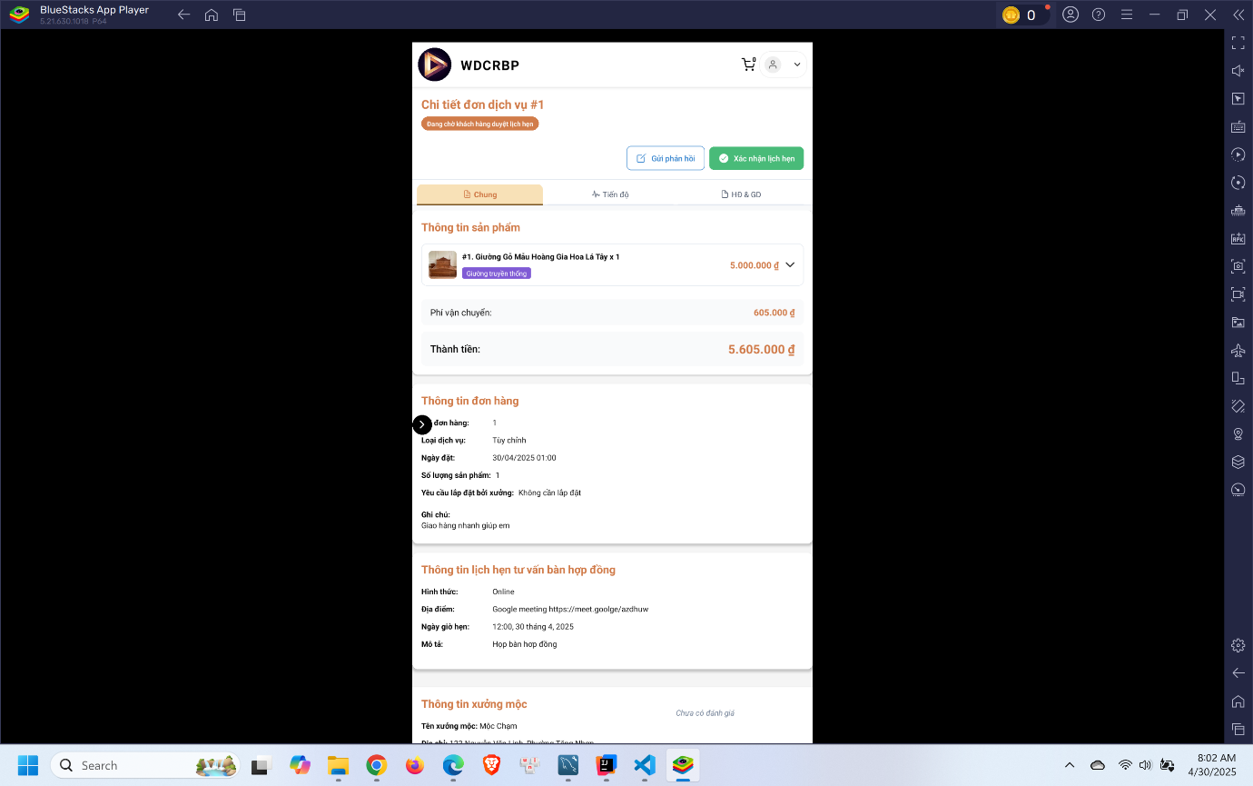
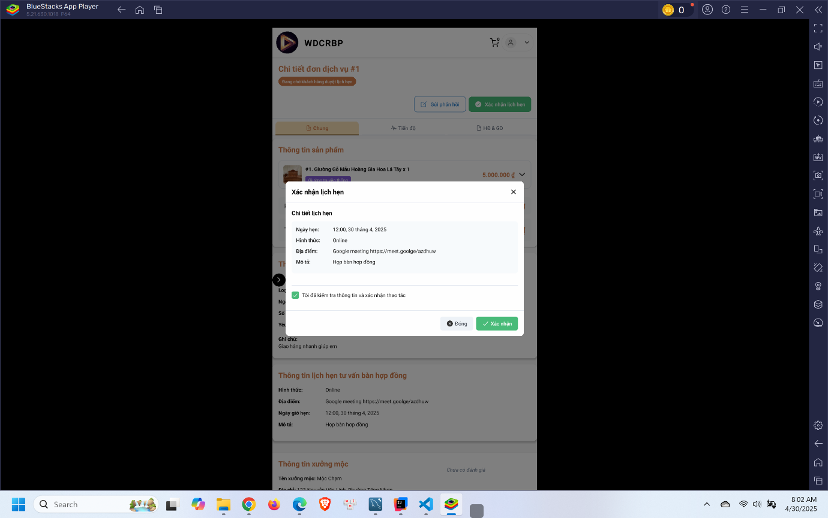
- Click “Xác nhận lịch hẹn”
- Click “Xác nhận”

3.3.2.4 Woodworker update the contract
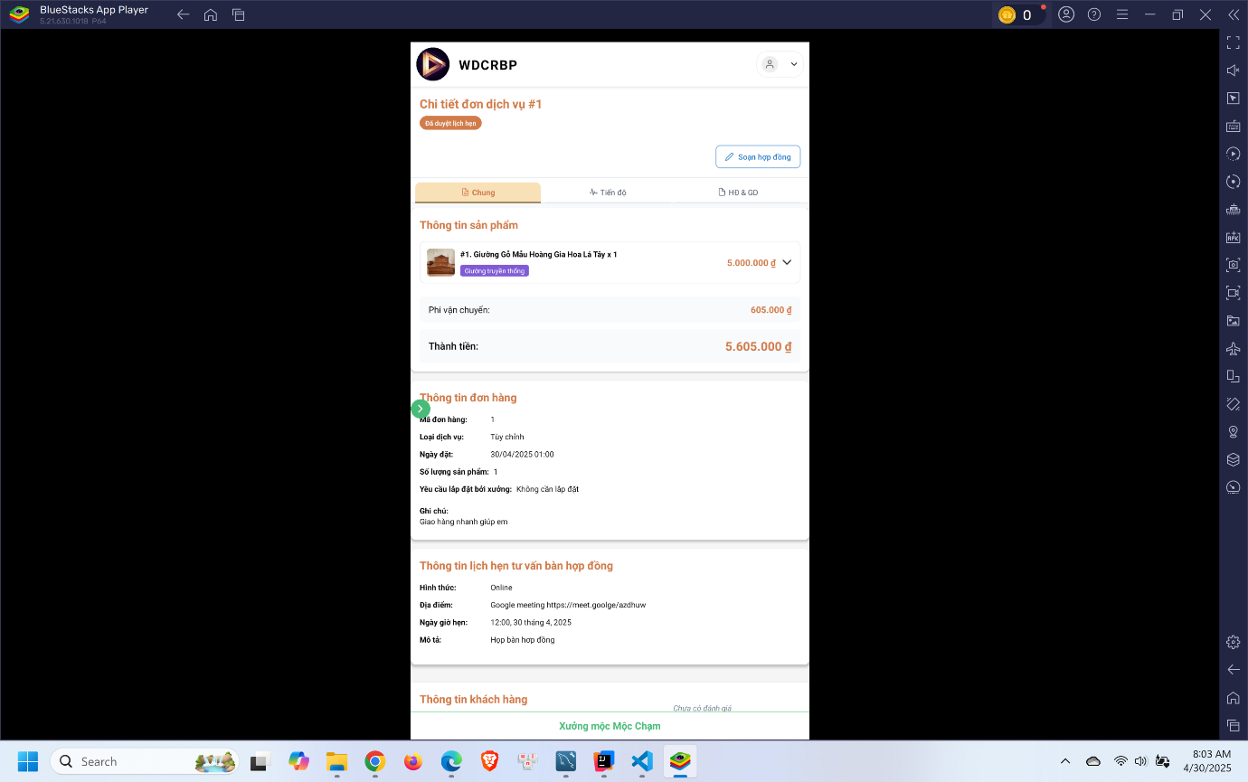
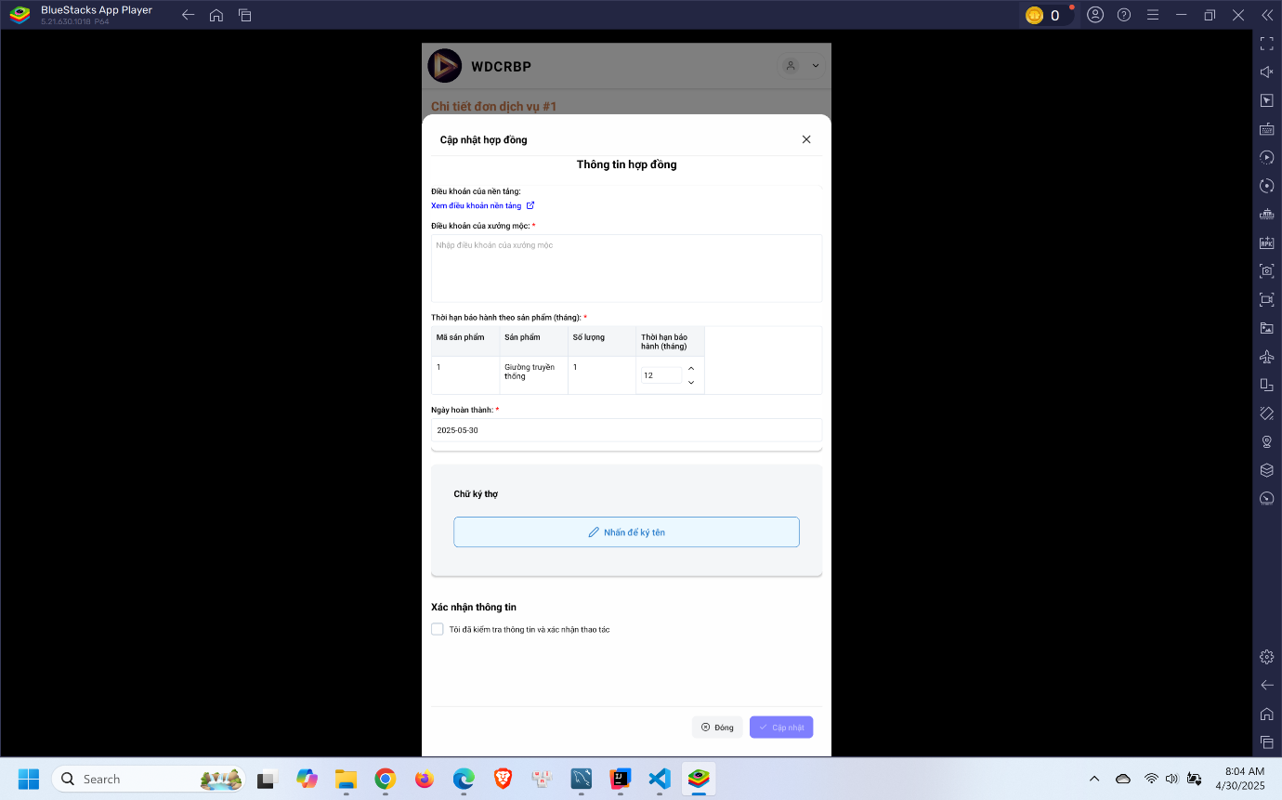
- Click “Soạn hợp đồng”
- Enter the form and sign in the box
- Click “Cập nhật”

3.3.2.5 Customer confirm contract and process payment
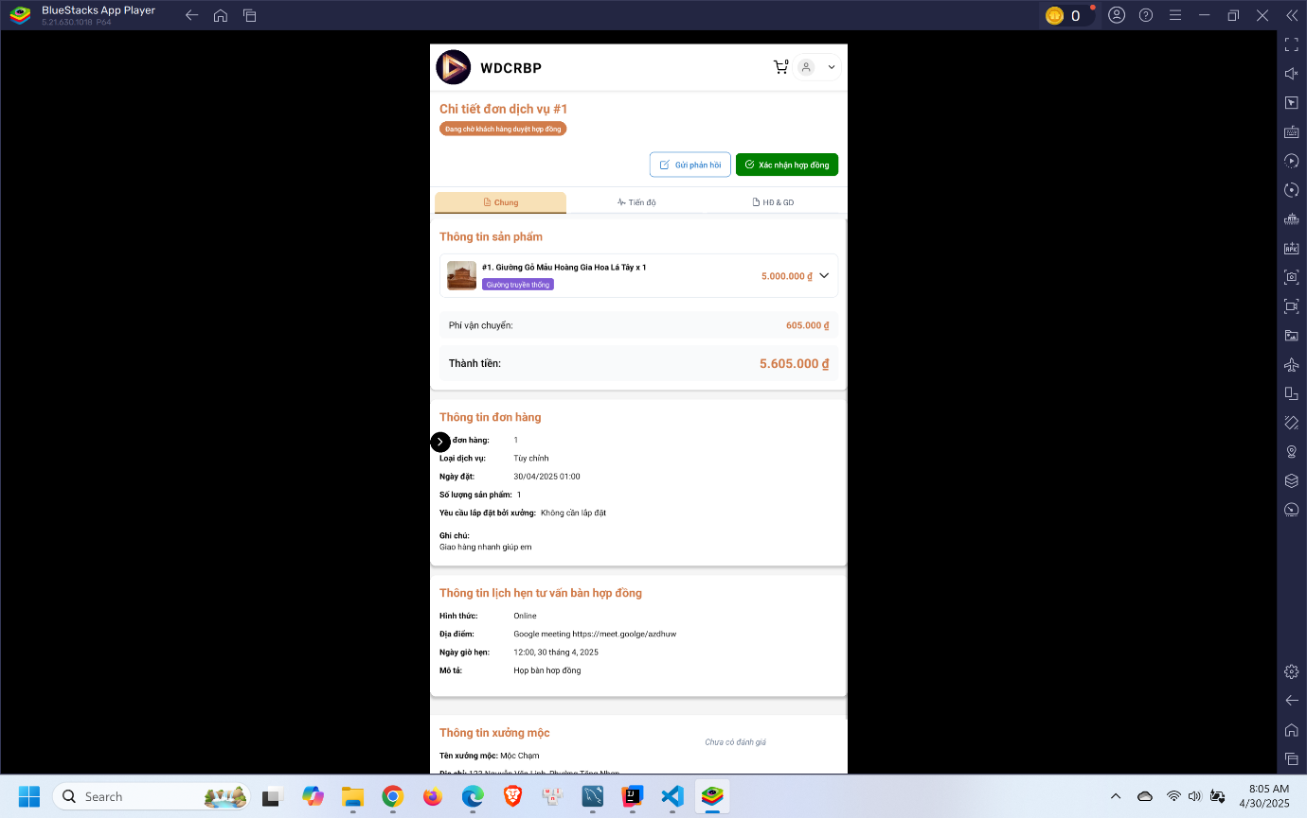
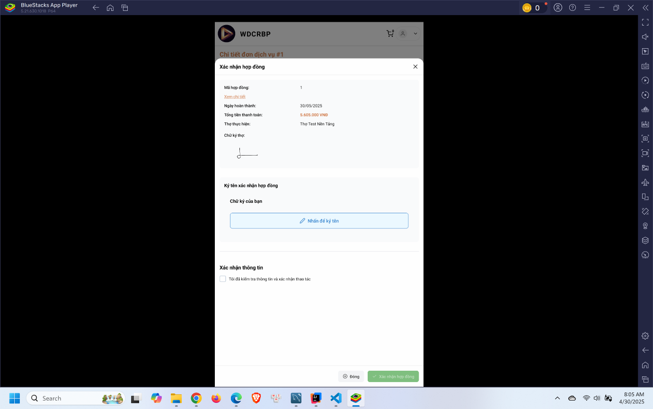
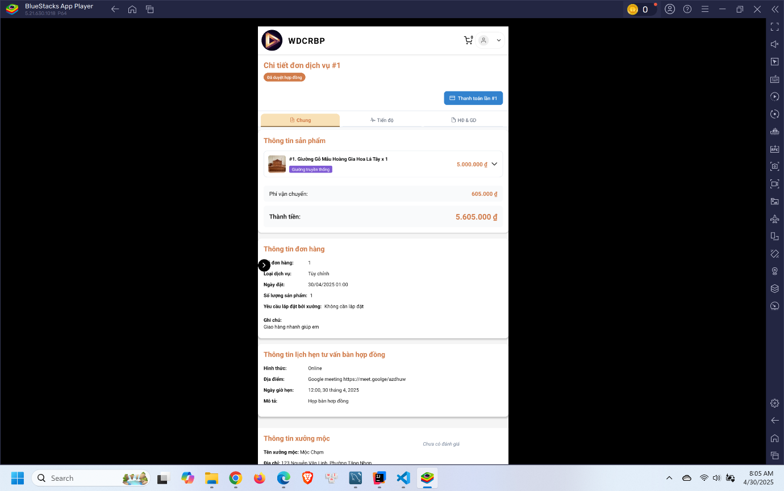
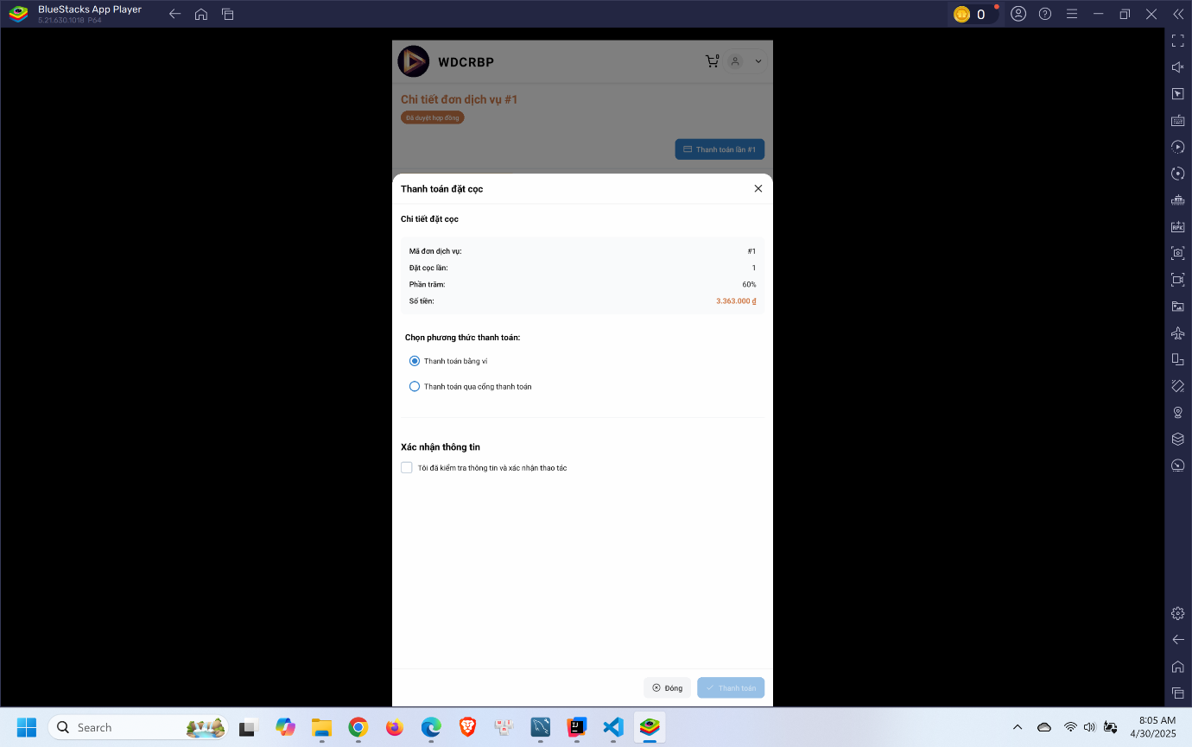
- Click “Xác nhận hợp đồng”
- Check information and sign in the box
- Click “Xác nhận hợp đồng”
- Click “Thanh toán”
- Choose payment method and process payment

3.3.2.6 Woodworker upload the finished product image
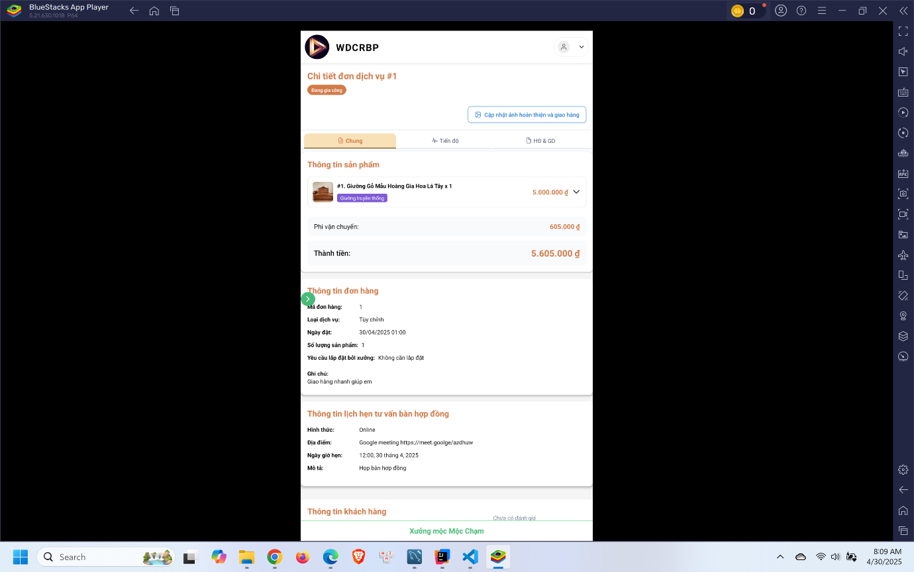
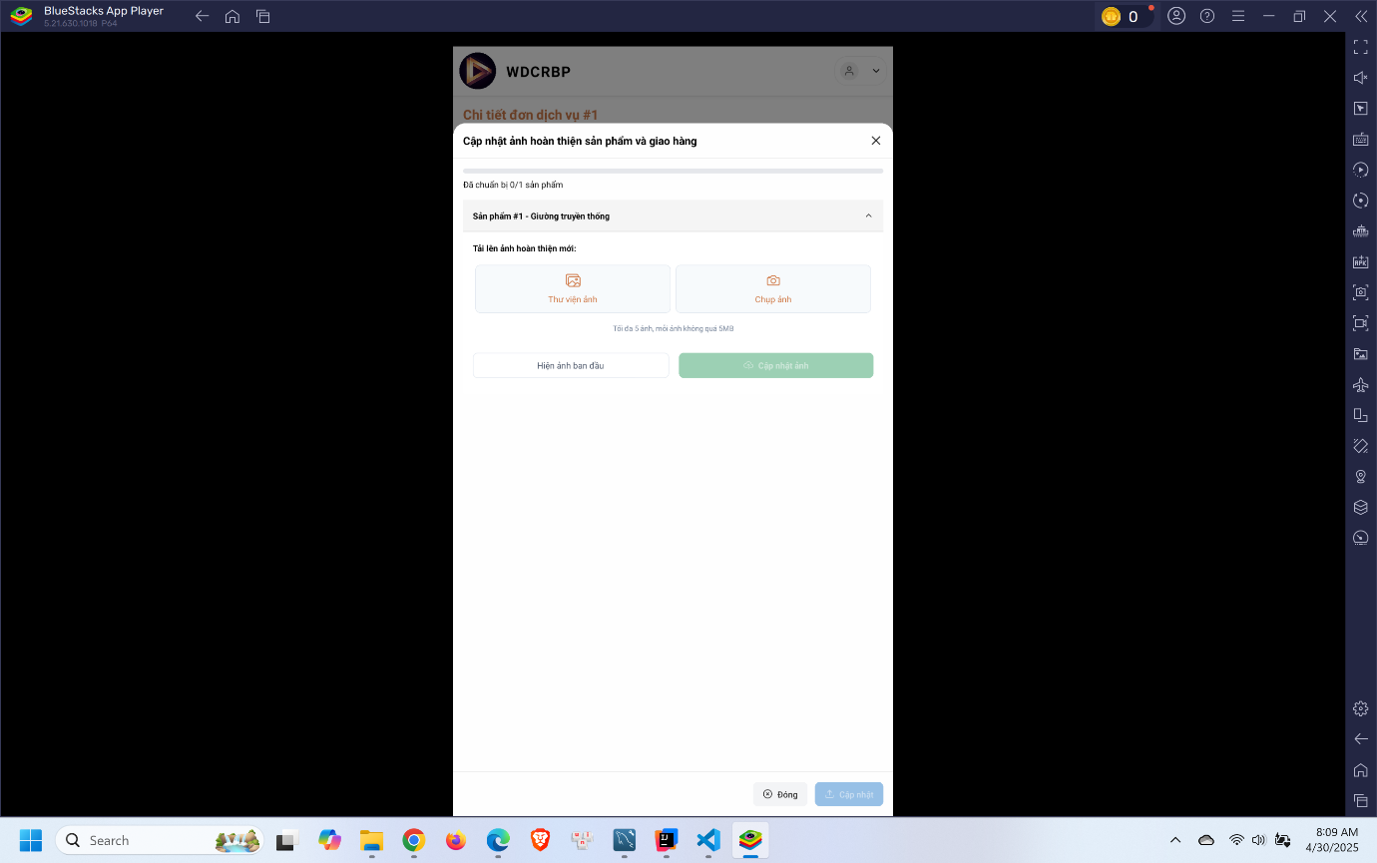
- Click “Cập nhật ảnh hoàn thiện và giao hàng”
- Upload images and click “Cập nhật”

3.3.2.7 Customer confirm receive product and process payment
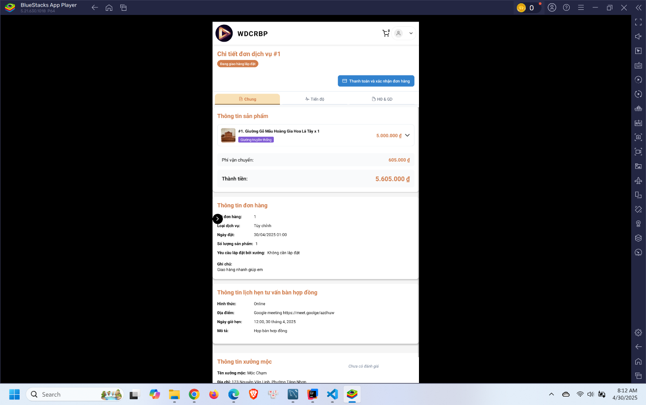
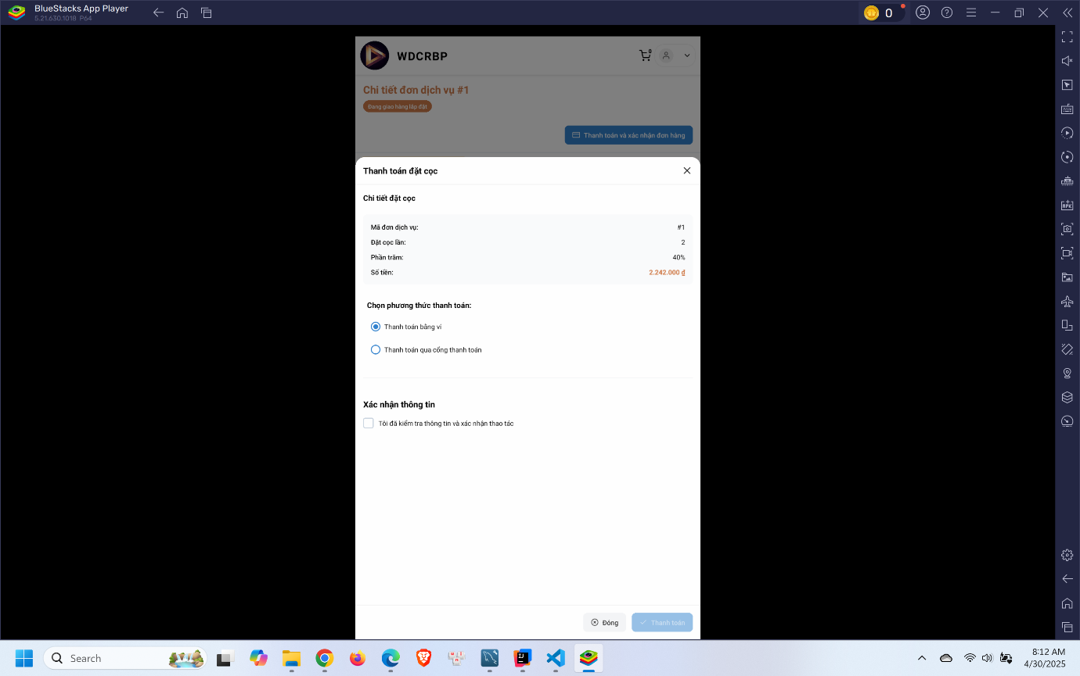
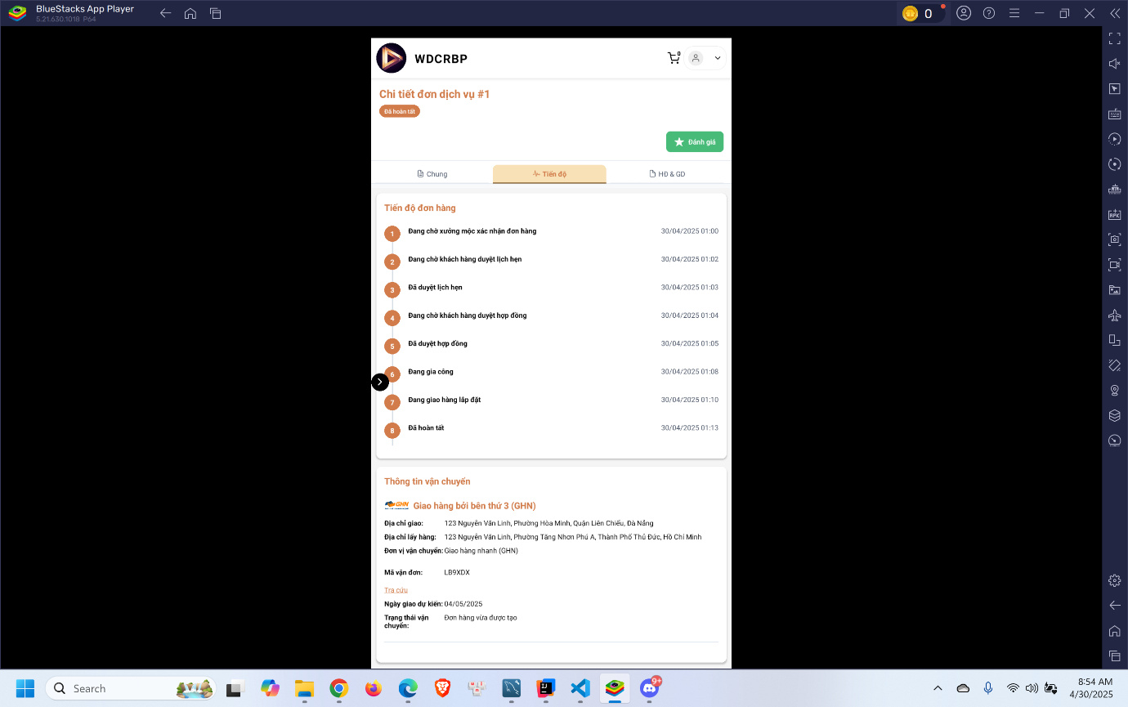
- Click “Thanh toán và xác nhận đơn hàng”
- Choose payment method and process payment

3.3.3 Guarantee Service Booking Feature

3.3.3.1 Customer request a guarantee order
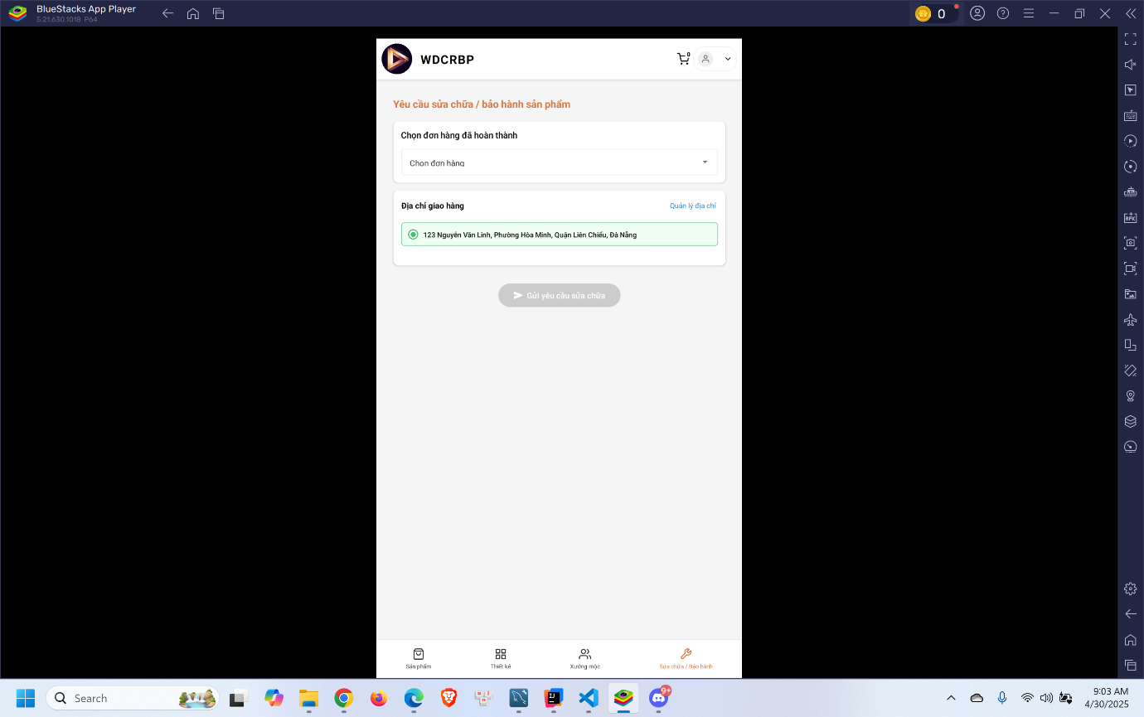
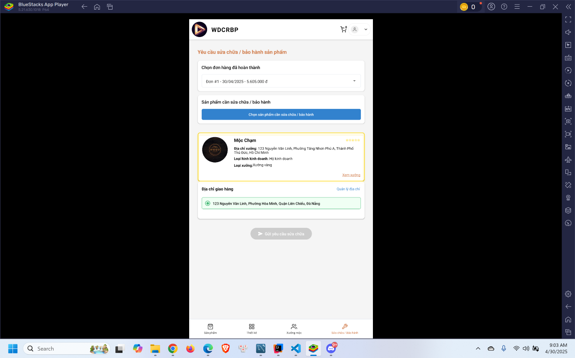
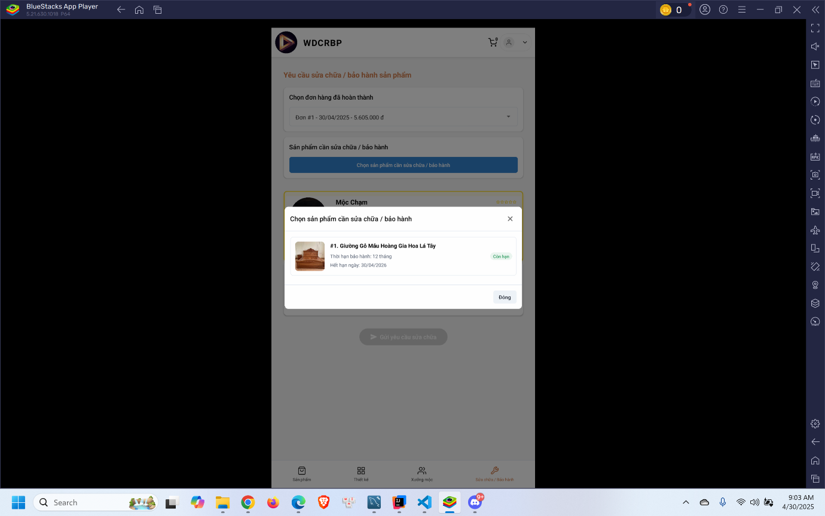

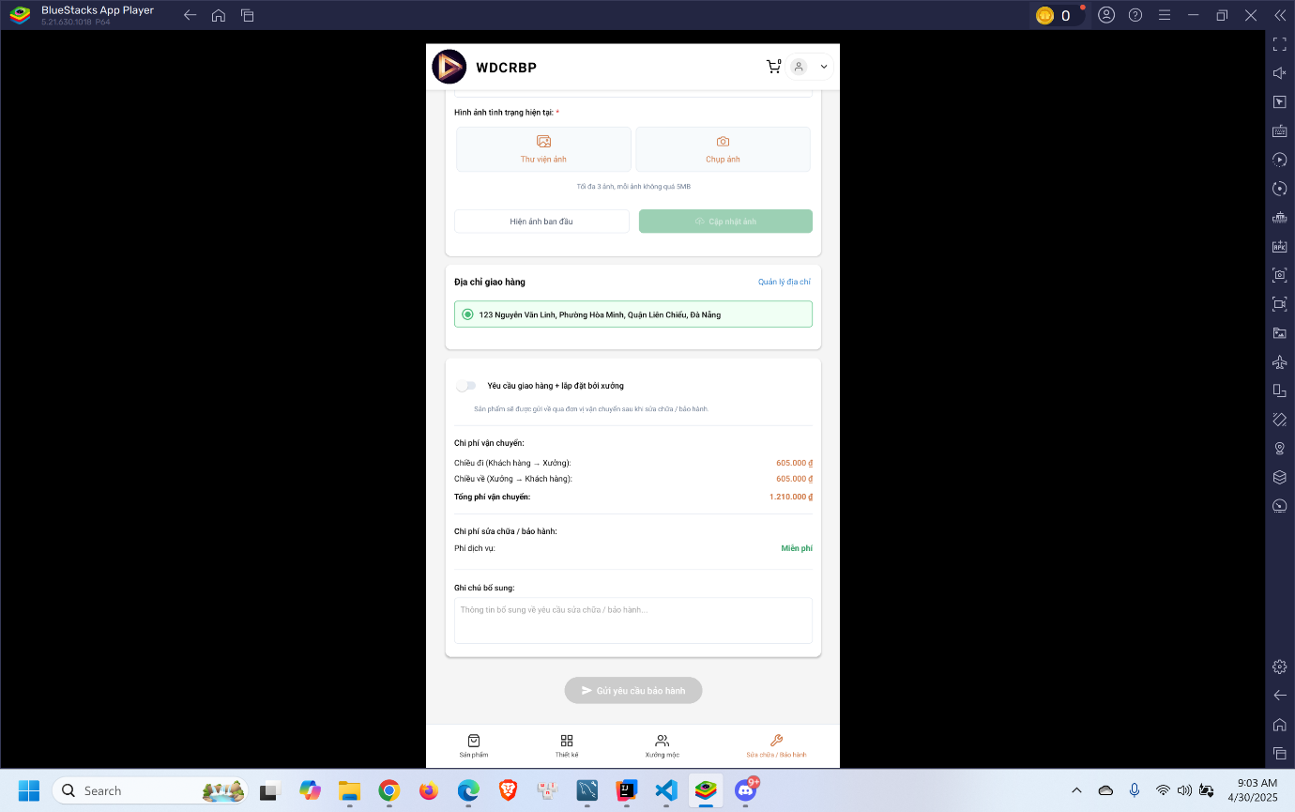
- Click “Sửa chữa / bảo hành” in the menu
- Select order to request
- Select product to request
- Fill in the form and click “Gửi yêu cầu bảo hành”

3.3.3.2 Woodworker accept the guarantee order
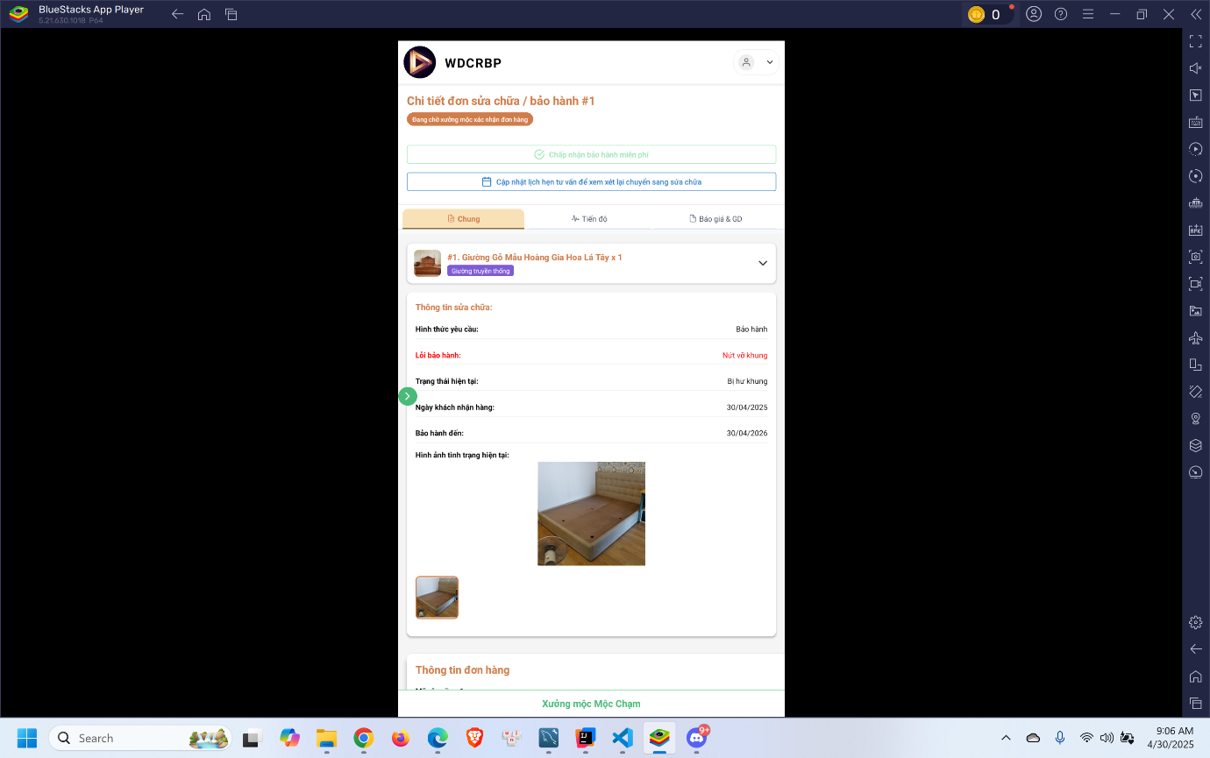
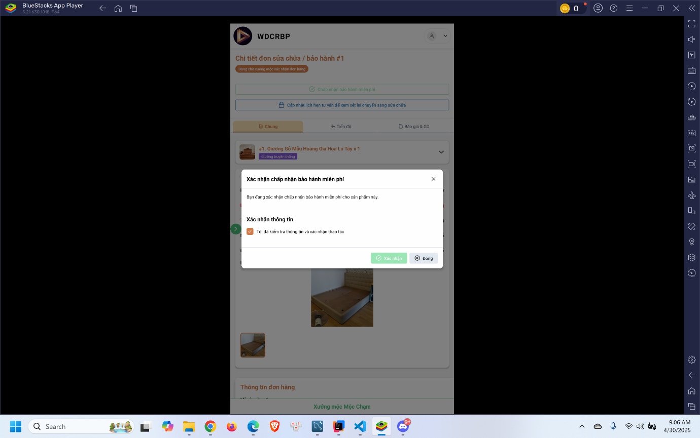
- Click “Chấp nhận bảo hành miễn phí”
- Click “Xác nhận”

3.3.3.3 Woodworker confirm receive product
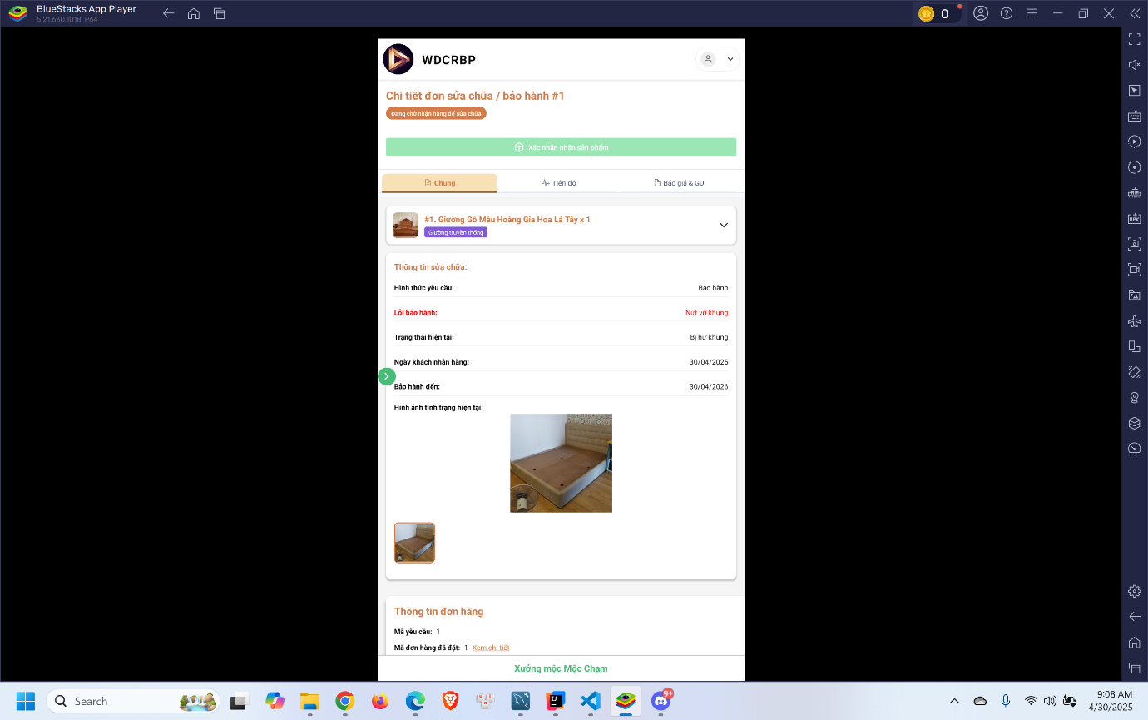
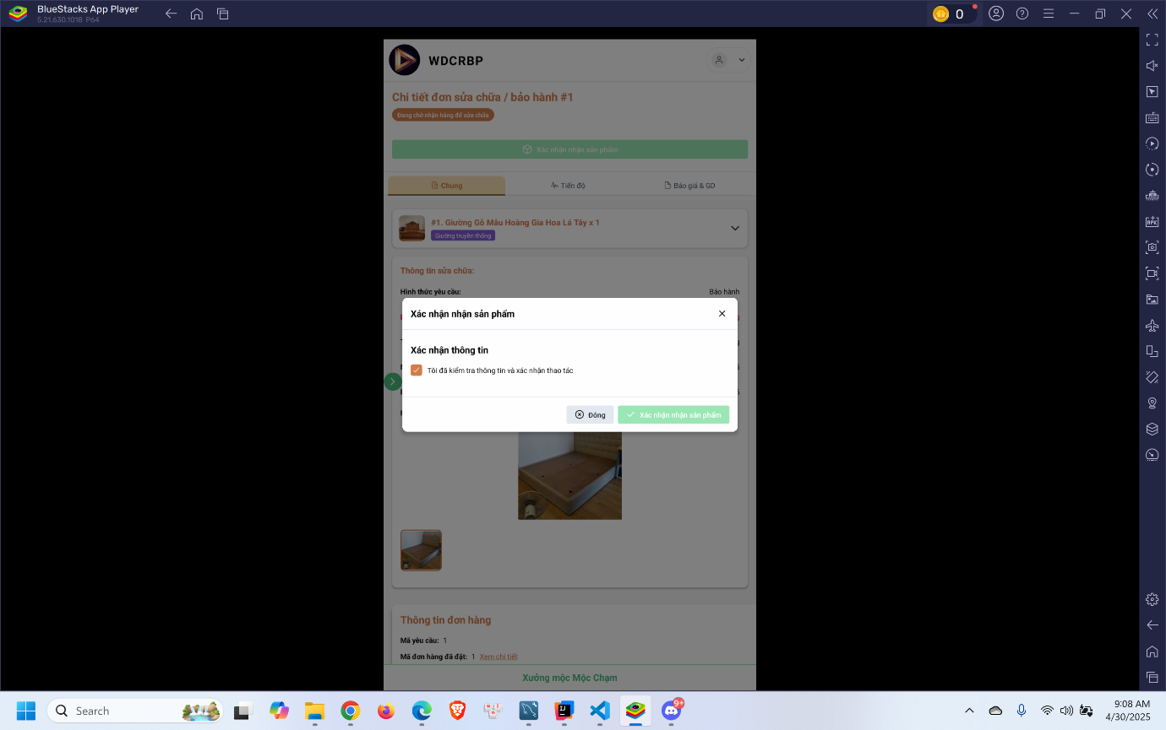
- Click “Xác nhận nhận sản phẩm”
- Click “Xác nhận”

3.3.3.4 Woodworker confirm repair finish
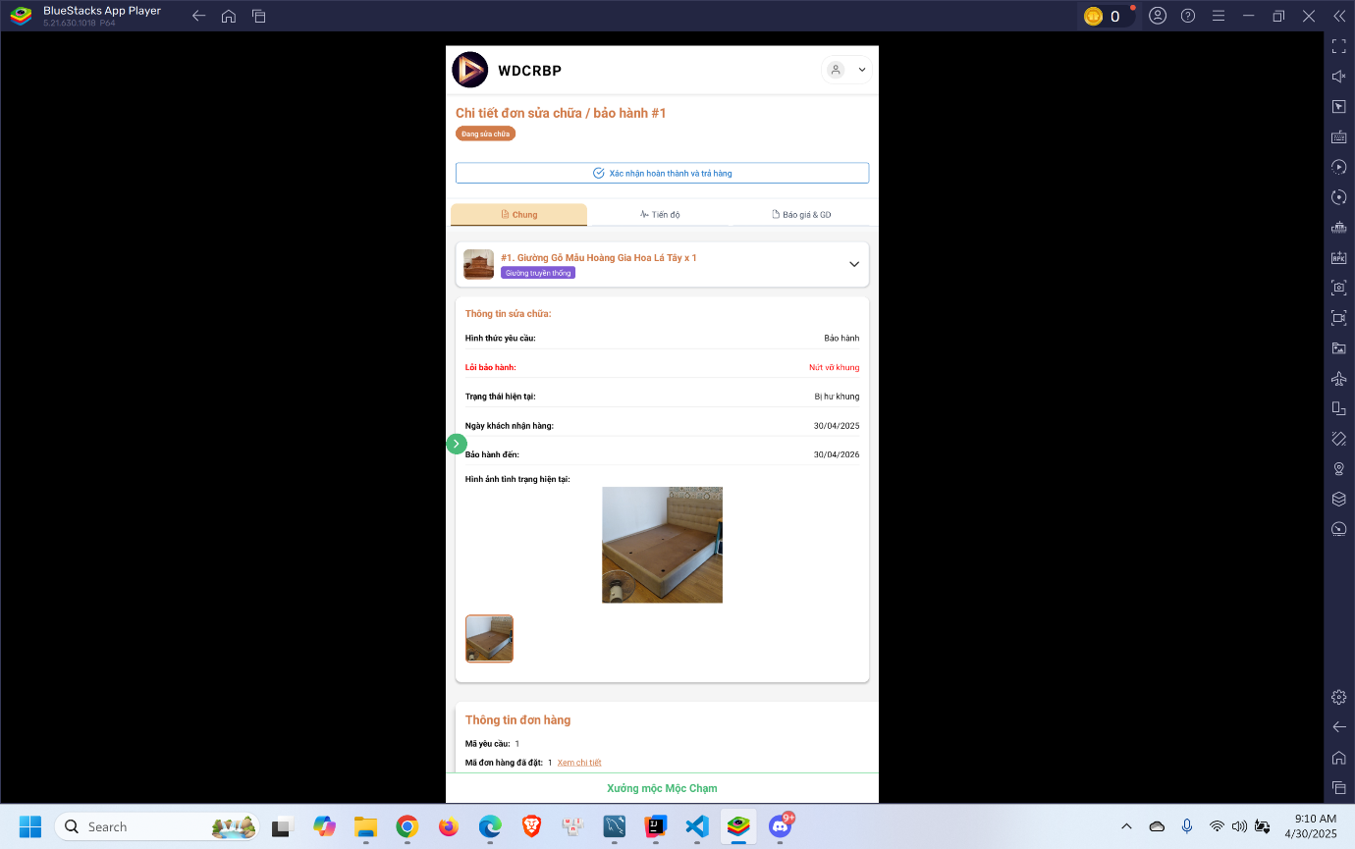
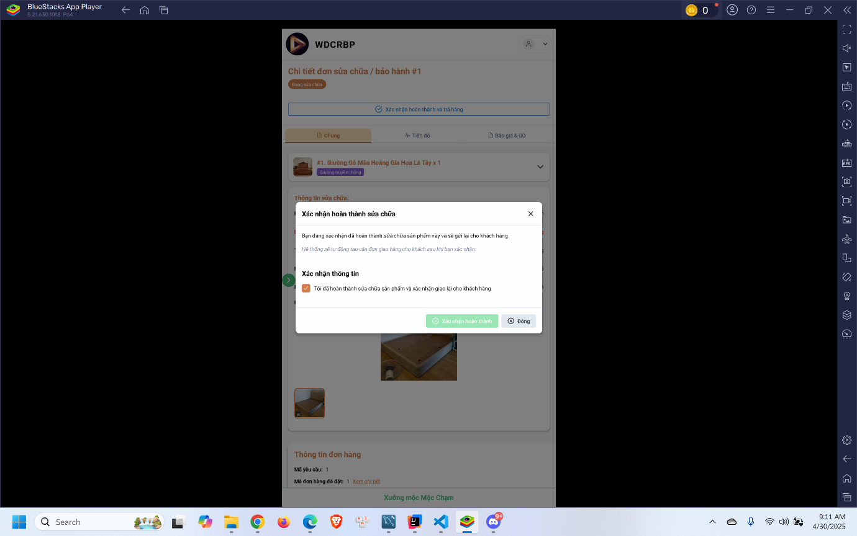
- Click “Xác nhận hoàn thành và trả hàng”
- Click “Xác nhận hoàn thành”

3.3.3.5 Customer confirm receive product and process payment
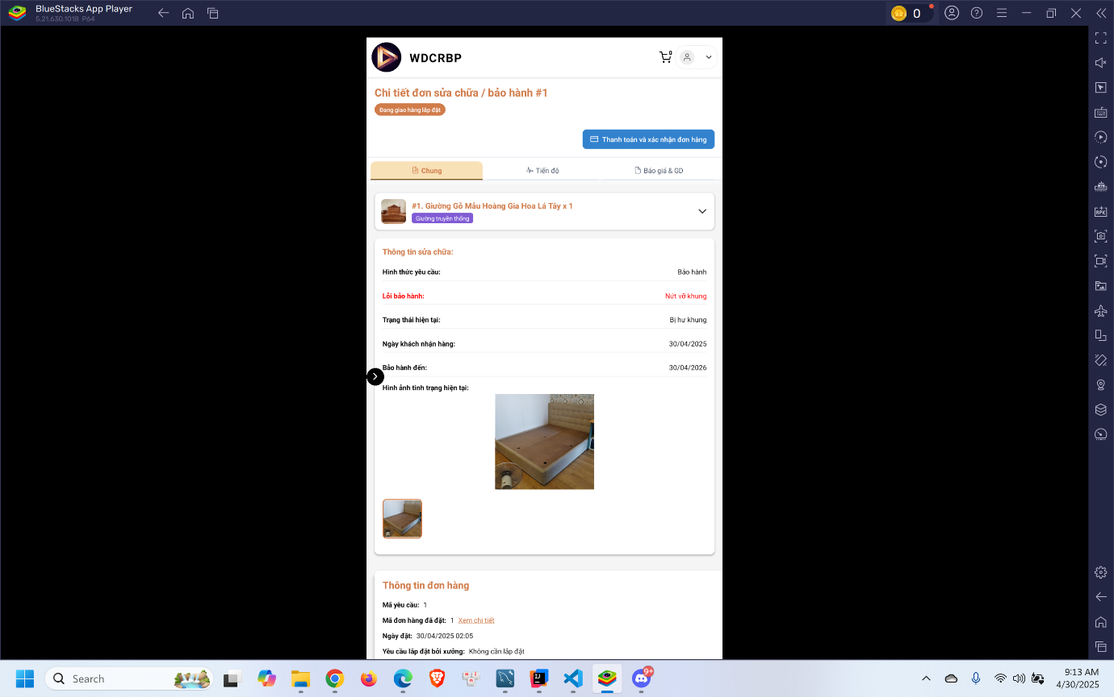
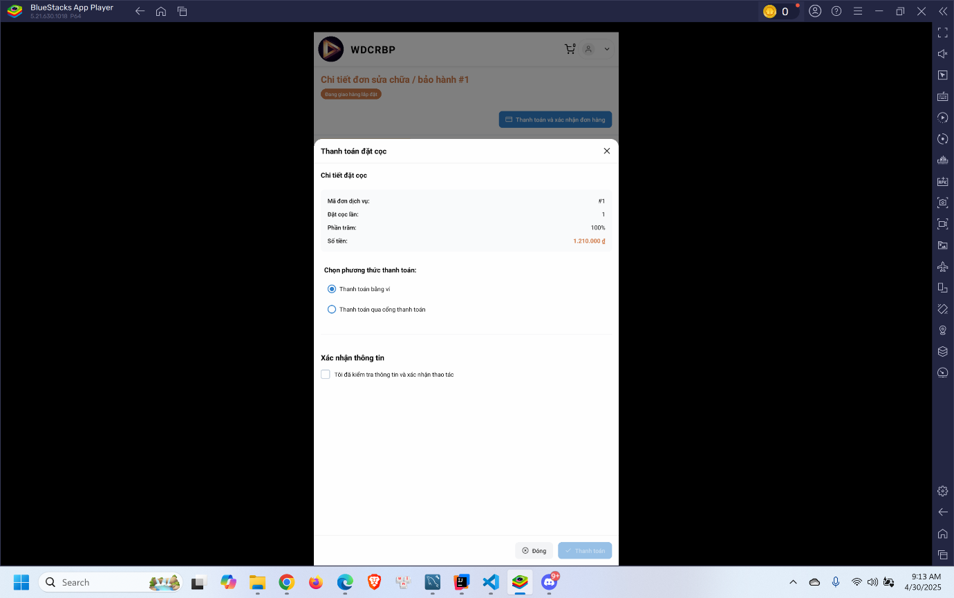
- Click “Thanh toán và xác nhận đơn hàng”
- Choose payment method and process payment

